**SSLEP Strategic Programme Management Group**

**Tuesday 24th August 2021**

**Getting Building Fund Q1 2020-21 report**

**Getting Building Fund – programme changes**

The underspend from the withdrawn scheme and the re-scoped Powering Up Enterprise scheme has been allocated to 4 contingency schemes, along with additional SSLEP funds to enable all 4 schemes to progress (this will be classed as “other match”). MHCLG has approved the Change Request.

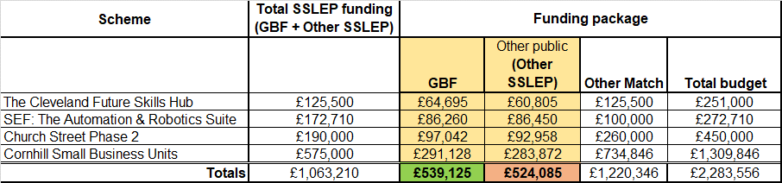

**GBF schemes**

A total of 14 schemes currently have LGF funding allocated.



**Drakelow Park** - de-allocation of GBF from SSLEP to D2N2 LEP:

* A paper proposing de-allocation was ratified by Executive Board on 15th July; a change request to MHCLG to request de-allocation/re-allocation of GBF was submitted on 26/07/21. MHCLG have subsequently approved the request on 29/07/21. A legal assurance agreement between SSLEP and D2N2 is pending.
* The de-allocation of Drakelow Park will significantly de-risk the scheme for SSLEP and allow D2N2 greater control.

The charts below exclude Drakelow:

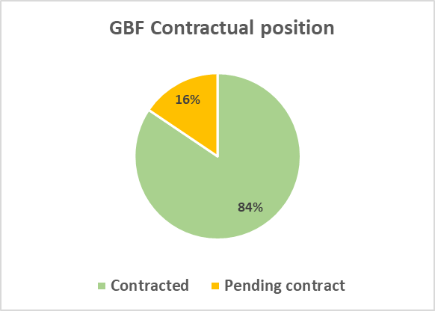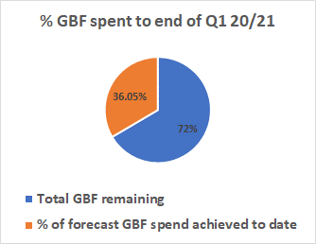

**Programme finances**

* GBF forecast spend by end of Q1: £9.5m
* GBF actual spend by end of Q1: £6.7m
* % of total GBF allocation spent to date: **36%**

**Getting Building Fund – District spread**

Notes:

1. includes Drakelow
2. does not include additional non-GBF SSLEP funding)

**Match funding**: Schemes are being encouraged to spend their GBF allocation first and match funding afterwards, to ensure all GBF is spent before the deadline of March 2022. However, a small amount of match funding has already been reported (£686,322 which is 1.19% of the total match forecast). Match funding will be reported in due course – there is a process in place to capture this.

**Outputs**

Most schemes are still in the early stages or pending start; however, the first outputs were delivered in Q4: LSTP: 1.1Km of cycling /pedestrian enhancements and Keele IC7 reported 17 construction jobs in Q1. Outputs will be reported as they are delivered.

**Key risks raised in Q1, for the attention of SPMG:**

* **Contracting**: new risk added: As the contingency schemes have only very lately been approved, there is a risk that implementing the schemes and achieving GBF spend by the deadline of March 2022 may prove too challenging. Schemes that had originally planned to deliver during a period of 12 to 18 months now have only 7 months.

There have been some delays in receiving the Heads of Terms from schemes, without which contracting cannot commence. 4 schemes still have funding agreements outstanding:

* Cornhill Small Business Units: no HoTs have been received to date.
* Powering Up Enterprise: revised draft contract issued to SoTCC on 19/07/21; SoTCC advise that they are still in discussions with GenR8, a third party partner.
* Church Street Gaming Hub: HoTs received 04/08/21, contract now in draft.
* Cleveland Works – contracted drafted, awaiting completion.

**Further details are available for GBF schemes:**

Details for each scheme can be viewed in the appendix:

* **Appendix:** **GBF Progress dashboard Q1 2021-22 v2 programme**

**Report prepared by** Sharon Palphreyman  
**Job Title:** SSLEP Programme Manager