Stoke-on-Trent and Staffordshire
ESIF ESF Delivery Programme
2014 – 2023
(part of the 2014-2020 European Structural and Investment Fund programme)

INDEX
- Introduction page 3
- Learner Journey – Pathway Model page 6
- Commissioning Leads page 7
- Key Contacts page 8
- Programme Overview page 10
- Delivery Matrix page 23

- INTRODUCTION:
Background
The European Social Fund (ESF) is the European Commission’s main funding programme investing in people, with a focus on improving employment and education opportunities across the European Union.
Despite ongoing uncertainty around Brexit, funding from ESF still plays a key role in supporting the Stoke-on-Trent and Staffordshire Local Enterprise Partnership’s (SSLEP) priorities to raise skills levels and stimulate business growth.
The 2014-2020 EU Programme allocated £55 million ESF to be invested in skills, employability and social inclusion.
SSLEP produced a Commissioning Plan and Prospectus 2014-2020 that set out the ways of working with three Opt-in Organisations (OIOs) who procure, manage and provide the match funding for the ESF programmes locally. The three OIOs are the National Lottery Community Fund (formerly Big Lottery), Department for Work and Pensions (DWP) and Education & Skills Funding Agency (ESFA). Following rigorous Open and Competitive tendering processes in 2016 the three OIOs awarded 12 contracts in the SSLEP area for Round 1, totalling £37m. In addition Open Calls have been launched from SSLEP via the Managing Authority to commission a Higher Skills project, outcome to be announced and a Skills Hub which has been awarded to Staffordshire Chambers of Commerce. In March 2019 nine of the initial twelve contracts ended and the SSLEP via the ESFA commissioned and procured four new contracts.
It is the intention that the effective use of European Social Fund (ESF) funding will unlock the potential of the current and future local workforce through a demand-driven approach to providing skills and matching those skills to employment opportunities. SSLEP and its partners are committed to delivering ESF programmes that will ensure that all residents, regardless of their personal circumstances, are included and can start on a journey to sustainable employment.
SSLEP has identified five key interlinked areas for intervention that have developed into a pathway model for programme delivery that is summarised on page 6 of this Delivery Programme Document.
This document is a simple guide to ESF services provided in the SSLEP area, it sets out the prime contractors and their local delivery partners providing learning, training and employability options for residents and businesses in the area. The intention is to refresh this document on a quarterly basis, the latest version is available on the Stoke-on-Trent & Staffordshire LEP website.

Round 1 Achievements
The table below summarises the achievements as at March 2019 against the overall outputs commissioned through the opt-in partners up to Dec 2019:
Key Outputs | Target | Achieved
total learners engaged | 18,609 | 19,604
total progressions * | 9,401 | 9,015
total SMEs engaged | 2,998 | 1488
*Progressions to Apprenticeship, Traineeship, employment, education and upskilling.
Further breakdown of achievements:
Total starts and progressions by district: July 2016 – March 2019
Geography | Number of Starts to March 2019 | % number of Total Starts | Number of Progressions to March 2019 | % number total Progressions
Cannock Chase | 1876 | 10% | 733 | 8%
East Staffordshire | 1393 | 7% | 695 | 8%
Lichfield | 1046 | 5% | 364 | 4%
Newcastle-under-Lyme | 1903 | 10% | 856 | 9%
South Staffordshire | 637 | 3% | 251 | 3%
Stafford | 1793 | 9% | 792 | 9%
Staffordshire Moorlands | 887 | 5% | 493 | 5%
Stoke-on-Trent | 8070 | 41% | 3992 | 44%
Tamworth | 1003 | 5% | 385 | 4%
Out of Area | 996 | 5% | 454 | 5%
Total | 19604 | 100% | 9015 | 100%

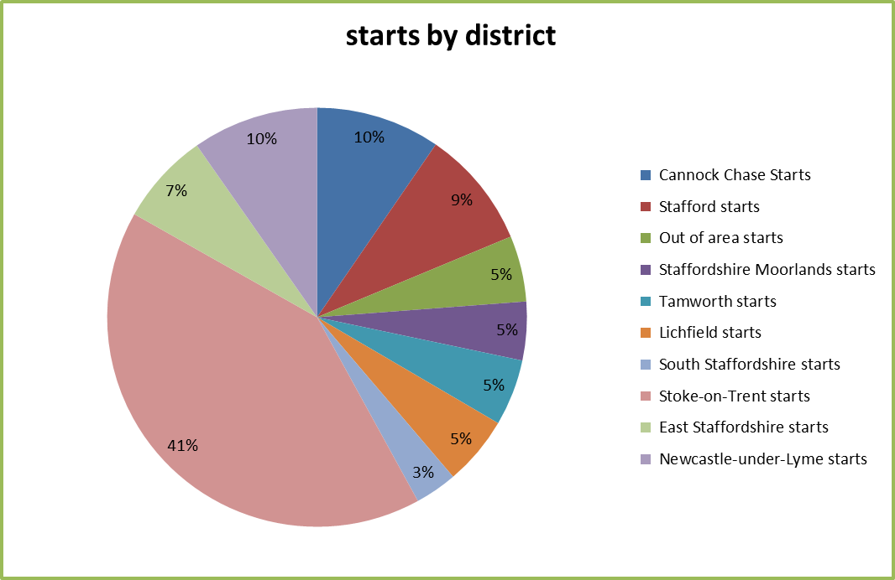
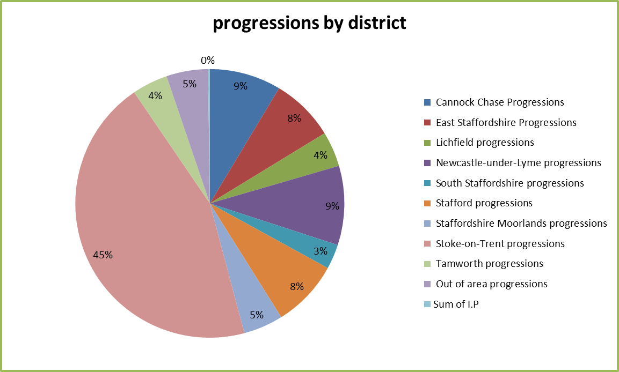

Round 2 Outputs
The SSLEP has agreed to opt-in for a second round of ESF training and skills provision with the ESFA and is in discussion with the National Lottery Community Fund to extend the Building Better Opportunities Projects to September 2022. Round 2 ESFA programme areas include Skills Support for the Unemployed, Support for young people who are NEET, Community Grants, Skills Support for the Workforce and Skills Support for Redundancy. There is no provision in Round 2 with DWP Opt-in Organisation.
Key Outputs to be delivered are:
Key Outputs | Target
Total Learners engaged | 8,021
Total Progressions * | 3,763
*progressions include employment, apprenticeship, traineeship and upskilling.

- Learner Journey – Pathway Model
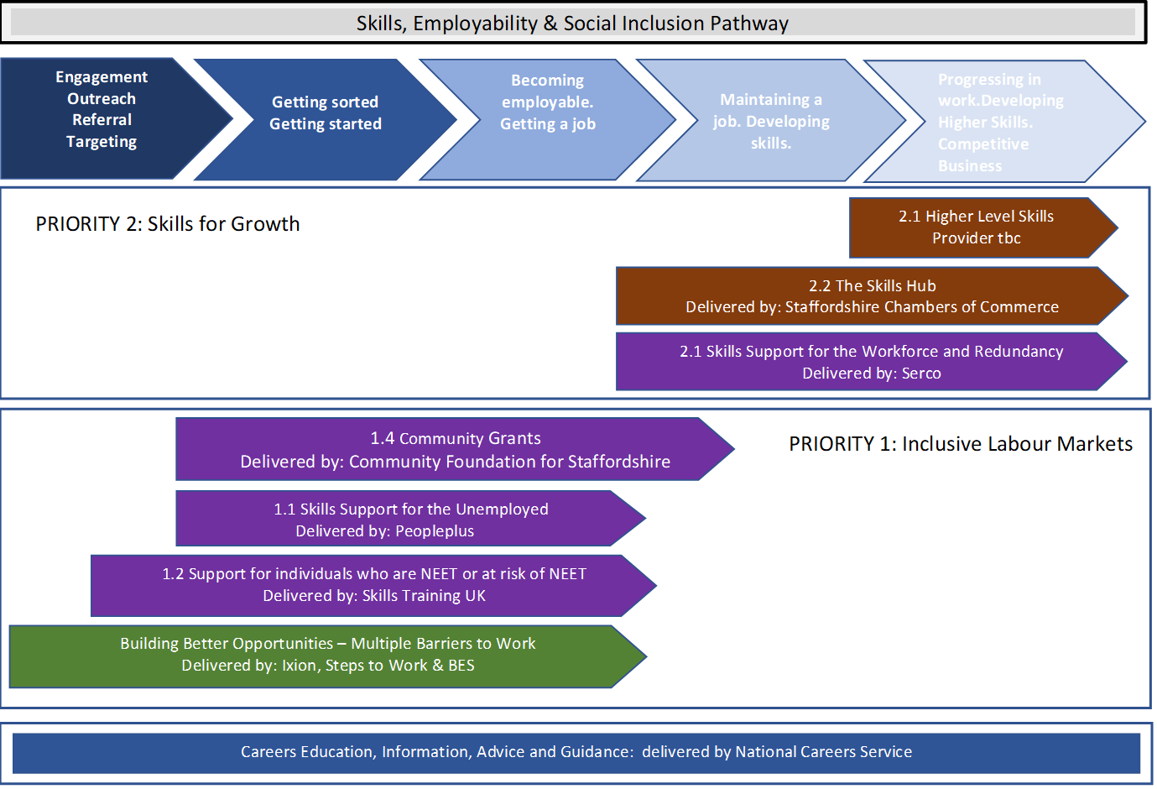

- Commissioning Lead Contacts
Stoke-on-Trent & Staffordshire ESF Commissioning
ESF Programme |  | Anthony Baines | Staffordshire County Council
National Lottery Community Fund Opt-in programme |  | David Poole | Staffordshire County Council
ESFA Opt-in programme |  | Caroline Mairs | Stoke-on-Trent City Council
Provider Relationship Lead Contacts
Stoke-on-Trent & Staffordshire ESF Provider Relationship Team
Lead Provider | Programme | Staffordshire County Council | Stoke-on-Trent City Council
Steps to Work | Evolve | David Poole/Giuliano Montinaro | Stephanie Brough/Hope Thomas
BES | Team Staffordshire-Stafford & South Staffordshire | David Poole/Giuliano Montinaro | Stephanie Brough/Hope Thomas
Ixion | Connecting Choices-Stoke-on-Trent & Staffordshire | David Poole/Giuliano Montinaro | Stephanie Brough/Hope Thomas
People Plus | Skills Support for the Unemployed | Anthony Bamsey/Giuliano Montinaro | Hope Thomas/Katie Rogers
Skills Training UK | Support for Individuals who are NEET or at risk of NEET | Alison Matthews/Linda Wilshaw | Stephanie Brough/Hope Thomas
Community Foundation for Staffordshire | Community Grants | David Poole/Giuliano Montinaro | Stephanie Brough/Katie Rogers
Serco | Skills Support for the Workforce | David Poole/Linda Wilshaw | Katie Rogers/Hope Thomas
 | Skills Support for Redundancy | Anthony Bamsey/Giuliano Montinaro | Katie Rogers/Hope Thomas
Staffordshire Chambers of Commerce | Skills Hub | Chris Bamsey/Linda Wilshaw | Katie Rogers/Stephanie Brough

- Key Contacts
Organisation | Contact | Job title | Telephone | Email
DWP | Karen Manuel | Senior Employer and Partnerships Leader | 07500 786148 | karen.manuel@dwp.gov.uk
DWP | Jon Murphy | Programmes and Provision Manager | 01782 382119 | jonathan.murphy3@dwp.gov.uk
The National Lottery Community Fund | Tim Birch | EU Policy & Stakeholder Manager | 03454 102030 | tim.birch@tnlcommunityfund.org.uk
ESFA | Diane Jones | ESF Delivery Manager |  | diane.jones@education.gov.uk
Staffordshire County Council | Anthony Baines | Assistant Director for Skills and Employability | 01785 895984 | anthony.baines@staffordshire.gov.uk
Staffordshire County Council | Anthony Bamsey | Head of Employability skills | 01785 278645 | Anthony.bamsey@staffordshire.gov.uk
Staffordshire County Council | David Poole | Head of Employer Skills Partnerships | 01785 854058 | David.poole1@staffordshire.gov.uk
Staffordshire County Council | Chris Bamsey | Head of Apprenticeships and Technical Skills | 01785 278659 | Chris.bamsey@staffordshire.gov.uk
Staffordshire County Council | Alison Matthews | Head of 16- 18 Participation and Skills | 01785 278901 | Alison.matthews@staffordshire.gov.uk
Staffordshire County Council | Linda Wilshaw | Skills and Further Learning Officer | 01785 277388 | linda.wilshaw@staffordshire.gov.uk
Staffordshire County Council | Amanda Darlington | Community Learning Manager | 07800 626586 | Amanda.darlington@staffordshire.gov.uk
Staffordshire County Council | Giuliano Montinaro | Skills and Further Learning Officer | 01785 277233 | Giuliano.montinaro@staffordshire.gov.uk
Stoke-on-Trent City Council | Caroline Mairs |  | 01782 231163 | Caroline.mairs@stoke.gov.uk

Organisation | Contact | Job title | Telephone | Email
Stoke-on-Trent City Council | Hope Thomas | ESF Project Officer | 01782 231357 | hope.thomas@stoke.gov.uk
Stoke-on-Trent City Council | Stephanie Brough | ESF Project Officer | 01782 231158 | stephanie.brough@stoke.gov.uk
Stoke-on-Trent City Council | Katie Rogers | Employment and Skills Development Officer | 01782 236109 | Katie.rogers@stoke.gov.uk
Stoke & Staffordshire LEP | Tom Hobbins | Communications Manager (Interim) | 01785 276832 | Tom.hobbins@staffordshire.gov.uk
Staffordshire County Council | Paul Dutton | Senior Campaign Officer (media) | 01785 854912 | Paul.dutton@staffordshire.gov.uk
Stoke-on-Trent City Council | Natalie Baker | Communications Officer | 01782 232395 | Natalie.baker@stoke.gov.uk
Stoke-on-Trent City Council | Hayley Webb | Communications Officer | 01782 235587 | Hayley.webb@stoke.gov.uk

- PROGRAMME OVERVIEW
National Lottery Community Fund Opt in
Project title | Evolve
Lead provider | Steps to Work
What’s on offer | Support for participants with multiple barriers to regain their confidence and move closer to the job market.
Who is eligible | Participants must be aged 16+ and unemployed or economically inactive.  People who are most at risk of social exclusion, including but not limited to:  - People with disabilities or long-term health conditions, people who are 50 or older, people from BAME communities, people with low skills or qualifications, people who live in areas of high unemployment, young people who are NEET, people living in single-adult households and people with caring responsibilities.
What is the delivery period | 3 January 2017 – 30 September 2022
What are the progression routes | Economically Inactive Participants become active job seekers  Training and Education  Employment
Where is it delivered | Lichfield, Cannock, Tamworth & East Staffordshire
Who are the delivery partners | partners as listed below
Programme Website | https://www.stepstowork.co.uk/Pages/FAQs/Category/evolve-team
Who do I contact to make a referral | Please contact the partner direct to make a referral
The Big Happiness Experiment:  Julie Mitchell |  | 07583 203444 | jules@bighappinesscic.com
Starfish Services Limited:  Debra Roache |  | 07534 149341 | debraroache@starfishservices.co.uk
Groundwork West Midlands:  Alan Bull |  | 0121 5305511 | alan.bull@groundwork.org.uk
Citizens Advice South East Staffordshire:  Julie Lloyd |  | 01543 254926 | office@sestaffs.cabnet.org.uk
Burton Mind:  Amina Miah |  | 01283 566696  07845 946135 | amina.miah@burtonmind.co.uk
Burton Albion Community Trust:  Sarah Evans |  | 07753455673 | sarah.evans@burtonalbionct.org
Landau:  Caroline Richardson |  | 07368 441545 | Caroline.richardson@landau.co.uk
Beacon Centre for the Blind:  Rachel Shaw |  | 01902 880111 | rshaw@beaconvision.org

Project title | Team Staffordshire – Stafford and South Staffordshire Building Better Opportunities
Lead provider | Business Enterprise Support (BES)
What’s on offer | Support for participants with multiple barriers to regain their confidence and move closer to the job market.
Who is eligible | Participants must be unemployed or economically inactive.  People who are most at risk of social exclusion, including but not limited to:  - People with disabilities or long-term health conditions, people who are 50 or older, people from BAME communities, people with low skills or qualifications, people who live in areas of high unemployment, young people who are NEET, people living in single-adult households and people with caring responsibilities.
What is the delivery period | January 2017 – June 2023
What are the progression routes | Employment, education and training.
Where is it delivered | Stafford & South Staffordshire
Who are the delivery partners | 9 delivery partners as listed below
Programme Website | www.bbostaffs.org
Who do I contact to make a referral | Call our dedicated number: 01902 696228 or email: BBOstaffs@gmail.com
Beam:  Mike Howell |  | 07572 099482 | mike.howell@beamstaffs.org
Business Enterprise Support:  David Gibson |  | 07737 115493 | davidg@enterprisesupport.org
F USE: |  | 01785 248733
South Staffordshire District Council:  Michelle Kettles |  | 01902 696503 | m.kettles@sstaffs.gov.uk
South Staffordshire Housing Association:  Clare Poulson |  | 07807342810 | claire.poulson@housingplusgroup.co.uk
Staffordshire Women’s Aid:  Sue Lee |  | 01785 782753 | sue.lee@staffordshirewomensaid.org
Support Staffordshire:  Jill Norman |  | 07495 736160 | Jill.norman@supportstaffordshire.org.uk
University Hospital North Midlands:  Ian Carruthers |  | 01782 672269 | Ian.Carruthers@uhnm.nhs.uk
Upper Moreton Rural Activities:  Carole Carney |  | 07960 407238 | Umra.cic@gmail.com

Project title | Connecting Choices Stoke-on-Trent & Staffordshire
Lead provider | Ixion
What’s on offer | Support for participants with multiple barriers to regain their confidence, become more socially included and move closer to or into the job market, training, education as well as other positive progression routes.
Who is eligible | Participants must be unemployed or economically inactive, age 19 or older (or young people who are aged 16–29 and who are not in education, employment or training (NEET) and young people aged 15-18 who are NEET or at risk of becoming NEET)  People who are most at risk of social exclusion, including but not limited to:  - People with disabilities or long-term health conditions, people who are 50 or older, people from ethnic minority communities, people with low skills or qualifications, people who live in areas of high unemployment, young people who are NEET, people living in single-adult households and people with caring responsibilities.
What is the delivery period | June 2017 – September 2022
What are the progression routes | A progression plan will be created for all those supported by the project to engage with other training, educations and complementary services provided by the below organisations: Princes Trust Outcomes Team, The Staffordshire and West Midlands CRC, The Carers Hub, Home Start, Gingerbread, Voices, Asist, Savana, One Recovery, Lifeline, T3, Midland Heart, Epic, Sanctuary Housing, Stafford College, Newcastle College, Acorn Training, South Staffs College.
Where is it delivered | Stoke-on-Trent, Newcastle-under-Lyme and Staffordshire Moorlands
Who are the delivery partners | 10 delivery partners as listed below broken down as  8 End to End Partners  3 Specialist partners (Genius Within, Starfish & Ixion Direct Delivery) who can only be accessed via a referral from a Connecting Choices End to End provision
Who do I contact to make a referral | Partners directly – To identify suitable referral route can refer to Ixions Website  https://www.ixionholdings.com/connecting-choices/
Ixion  Samantha Banks |  | 01782 756179 | samantha.banks@ixionholdings.com
Change Grow Live  Andrea Payne |  | 07920 536348 | andrea.payne@cgl.org.uk
Groundwork West Midlands  Alan Bull |  | 07970 725438 | Alan.bull@groundwork.org.uk
Achieve Training  Paul Berrisford |  | 01782 854968/ 279121/ 07818 037284 | pberrisford@achievetraining.org.uk
YMCA North Staffordshire  YMCA Moorlands |  | 01782 222376 | Chris.Deakin@ymcans.org.uk
RAD |  | 0845 688 2525 | employment@royaldeaf.org.uk
We Are With You  Vicky Lomas |  | 01782 956 119 | vicky.lomas@wearewithyou.org.uk
Stoke on Trent City Council |  | 01782 231217/  07879 115694 | Michelle.askey@stoke.gov.uk
Saltbox |  | 01782815879 | anna@saltbox.org.uk
Genius Within |  | 07512 145585  07512 139120 | fiona@geniuswithin.co.uk  nicola@geniuswithin.co.uk
Starfish |  | 01782 683136 | Val.nash@starfishpartnership.co.uk

ESFA Opt In
Project title |  | Positive Directions  (Support for Individuals who are NEET or at risk of NEET)
Lead provider |  | Skills Training UK
What’s on offer |  | The Positive Directions Programme is fully funded through the European Social Fund (ESF) and is available free to young people & young adults across Stoke & Staffordshire.  The programme will target those who are NEET and At Risk of becoming NEET.  Positive Directions will support ages between 15-24 to develop the capability of young people & young adults to progress either back into learning and remain in either Education, Apprenticeship, Traineeship or Employment.  The programme offers a range of exciting bespoke vocational courses, all tailored to the individual to boost opportunities and help progress in a positive direction.  Qualified advice and guidance tutors will offer intensive support covering aspects of: Media, Sexual Health, Who Am I & Resilience – All to enable young people and adults across Stoke & Staffordshire to achieve their potential.  Note: To be able to continue to support our learners during COVID-19, all providers are delivering a 50/50 remote & classroom blended learning approach, continuing to deliver 200 + online courses with on demand resources
Who is eligible |  | Young people aged 15 and 18 who are At Risk, and young adults who are NEET; ages 19-24  At Risk  Young person(s) in Education aged 15-18, who are At Risk of becoming NEET.  NEET  Young adult(s) who are not in Employment, Education or Training and are economically inactive, aged 19 -24.  Enhanced support for vulnerable young person(s) and young adults for whom who have SEN, and or leaving the care system and have multiple and complex life issues.
What is the delivery period | 1st April 2019 and run to 31st March 2023
What are the progression routes | Employment, Education, Apprenticeship, Traineeship
Where is it delivered |  | Stoke-on-Trent and Staffordshire
Who are the delivery partners |  | 11 delivery partners as listed below
Programme Website |  | Partners leaflets attached showing a blended approach to Regulated and Non-regulated bespoke courses.
Who do I contact to make a referral |  | Partners directly
Main contact |  |  | Contact Number | Contact Email
Pilot Training  Darren Carpenter |  |  | 07376.544.265 | darrencarpenter@pilot-uk.com
Stoke on Trent City Council  Positive Directions Team |  |  | 01782.234.333 | esfpositivedirections@stoke.gov.uk
Tempus Training  Sarah Parker |  |  | 01273.980.244 | s.parker@tempustraining.co.uk
ENTRUST  Katrina Browning |  |  | 07930.472.016 | katrina.browning@entrust-ed.co.uk
Acorn Training  Laura Sparrow |  |  | 07948.429.623 /  01530.519.400 | laura.sparrow@acorntraining.eu
Pathways First Limited  Michelle Roberts |  |  | 07722.125.692  01782.365.365 | Michelle.Roberts@Pathwaygroup.co.uk
PET-Xi  Leia Welland |  |  | 07341.562.979 | lwelland@pet-xi.co.uk
Achieve Training  Sarah Worman |  |  | 01782.279.121  07796.940.335 | sarahw@achievetraining.org.uk
LETS Academy  Mark Monet |  |  | 01782 286046 | m.monet@letsacademy.co.uk
The Training Initiative Group  Jayne Mannox |  |  | Office Number 01827.216.171 | enquiries@thetraininginitiative.co.uk
Quality Transport Training  Lloyd Phillips |  |  | Office Number  07714 402068 | lloyd.phillips@qtt.org.uk

Project title | Community Grants  (1.4 Community Grants)
Lead provider | Community Foundation for Staffordshire
What’s on offer | Funding to organisations who are moving people closer to the labour market, or into education or training.
Who is eligible | Organisations can apply if they are working in Staffordshire, are a charity, constituted community or voluntary group, social enterprise or company limited by guarantee.  We would prefer to fund organisations who have an income below £1m per annum, and less than 49 FTE employees, although we can make exceptions.  Organisations should be running projects that work with people who;  Are Long term unemployed or economically inactive  Have right to work in the UK  Are most at risk of social exclusion  Ideally projects should also include participants from at least one of these 4 priority groups;  Over 50’s  Ethnic minorities  People with disabilities  Women
What is the delivery period | April 2019 – March 2023
What are the progression routes | All funded organisations will be expected to create a learner and progression plan for their participants, which should be regularly reviewed. This plan should include pathways to at least one of the following; work, education, training or volunteering
Where is it delivered | Staffordshire, including Stoke on Trent
Who are the delivery partners | This programme is directly managed by The Community Foundation for Staffordshire.
Programme Website | https://staffordshire.foundation/grants/esfcommunitygrants/
Who do I contact to make a referral | For grant application enquiries please call the ESF Grants Team on 01785 339540 or email esf@staffordshire.foundation

Project title | 1.1 Skills Support for the Unemployed
Lead provider | PeoplePlus
What’s on offer | The project will support the following priority groups:  - Unemployed people – short and long-term.  - Unemployed, disadvantaged people (e.g. homeless people, people with drug or alcohol dependency, persistent returners to JSA/Universal Credit)  - Unemployed and inactive people with disabilities or health conditions (particularly existing claimants of incapacity benefit and ESA)  - Unemployed people 50 plus  - Ethnic minorities and those with basic language needs  - Ex-Offenders  - Lone Parents including those on Income Support (IS)  - Other people with children, including teenage parents (18-20 year olds)  Working with communities to improve social inclusion and employability, with a focus on areas of multiple deprivation and those who are hardest to reach.  Tailored programmes to suit the individual’s needs, delivering a wide range of courses from qualifications in Health and Social Care, Retail, Security, Logistics and Distribution, Customer Service, Hospitality and Catering, Tourism and Leisure, Maths and English (Functional Skills), IT and Employability/Personal Social Development.  Programmes include a mixture of classroom sessions and independent study in which learners will have access to their own online learning account and a dedicated coach, they will include sector endorsed professional development qualifications that will support the progressions journey into employment.
Who is eligible | Participants must be aged 16 or over, considered to be unemployed / inactive (any length of unemployment), they must be a legal resident and have the right to take paid employment in the UK.
What is the delivery period | April 2019 – March 2023
What are the progression routes | Paid Employment Progression  Education Progression  Apprenticeship Progression  Traineeship Progression
Where is it delivered | Throughout Staffordshire and Stoke-on-Trent.
Who are the delivery partners | Castleview Group Training Limited  Momentum Recruitment Limited  Pilot IMS  PET XI
Programme Website | https://www.peopleplus.co.uk/
Who do I contact to make a referral | Zara MacDougall  07435969935  zara.macdougall@peopleplus.co.uk
Castleview Group Training Limited |  | Helen Holmes | 0191 4324404
Momentum Recruitment Limited |  | Liz Seale | 01322 343515
Pilot IMS |  | Yann Floch | 0121 7940230
PET XI |  | Gary Drake | 0247 6420310

Project title | 2.1 Skills Support for the Workforce and Redundancy
Lead provider | Serco
What’s on offer | Skills Support for the Workforce  The programme will develop and upskill employees within SMEs. It will provide recognised accredited qualifications and bespoke training courses to enhance employees’ skills, increase the competitiveness of the business and boost the local economy.  - Training Needs Analysis will be completed to identify the skills needed to support the business  - Flexible Training, including on the job vocational training, taught learning, workplace assessment, distance learning and on-line training.  - Progression opportunities  - Can be more cost-effective than hiring skilled employees  - Increases employee confidence, motivation and productivity  - Improves employee loyalty and retention by making them feel valued  Skills Support for Redundancy  - Support businesses (of any size) that are undergoing industrial restructuring by providing skills and employability support for their employees who are At Risk of Redundancy.  - Supporting Recently Redundant individuals where initial contact through previous employers has not been possible.
Who is eligible | Skills Support for the Workforce  Participants must be aged 16 or over and be in paid employment within an SME. They must be legally resident and have the right to take paid employment in the UK. There are no prior attainment restrictions for participants.  Skills Support for Redundancy  Participants must be at risk of redundancy or have been made redundant in the last 3 months.
What is the delivery period | April 2019 – July 2023
What are the progression routes | In Work Progression,  Education Progression,  Apprenticeship Progression,  Progression into Work
Where is it delivered | Throughout Stoke-on-Trent and Staffordshire.
Who are the delivery partners | Acorn Training, Gateway Training, HIT Training, LETS Academy, Pathway First Ltd, Pilot IMS, Achieve Training, PTP Training, Siamo Ltd, Stoke-on-Trent City Council, Stoke-on-Trent College, The Construction Skills People, TCHC, The Portland Training Company, The TESS Group, WiseAbility.
Programme Website | https://www.serco-ese.com/skills-support-for-the-workforce/regions/stoke-on-trent-staffordshire
Who do I contact to make a referral | All referrals should be sent to skillssupport@serco.com or Dominic.Murphy2@serco.com – 07707294788
Acorn Training  Siobhan Clegg |  | 01782 827827 | Siobhan.clegg@acorntraining.eu
Gateway Training  Khalil Ahmed |  | 07866 769436 | Khalil@gatewayapprenticeships.com
Hit Training  Sara Taylor |  | 07508 908620 | sara.taylor@hittraining.co.uk
Lets Academy  Mark Monet |  | 01782 286046 | m.monet@letsacademy.co.uk
Pathway First Group  Shaheed Ladak |  | 0121 707 0550 | Shaheed@pathwaygroup.co.uk
Pilot IMS  Aesha Ali |  | 07505 480629 | aeshaali@pilot-uk.com
Achieve Training  Linda McQuade |  | 07748 762419 | lmcquade@achievetraining.org.uk
PTP Training  Paul Smith |  | 07980 740011 | paul.smith@ptp-training.co.uk
Siamo Group  David Bacon |  | 07740 378781 | d.bacon@siamogroup.com
Stoke on Trent Council  Kelly Tomlinson |  | 07557 848781 | kelly.tomlinson@stoke.gov.uk
The Construction Skills People Andrew Sheppard |  | 07866 109387 | andrew.sheppard@skillspeoplegroup.com
The Portland Training Co  Karl Shaw |  | 07748 180617 | Karl.shaw@portlandtraining.co.uk
The TESS Group  Lisa O’Reilly |  | 01604 210 500 | Lisa.oreilly@thetessgroup.com
WiseAbility  Jackie Moxom |  | 07809 340860 | Jackie.moxom@wiseability.co.uk
Stoke on Trent College  Jayne Beetham |  | 07786114083 | jbeet1sc@stokecoll.ac.uk
TCHC (The Consultancy Home Counties Ltd)  Yuen-Man Yau |  | 07720090207 | Yuen-man Yau <yuen-man.yau@tchc.net>

Open Calls
Project title | Stoke on Trent & Staffordshire Skills Hub
Lead provider | Staffordshire Chambers of Commerce
What’s on offer | The Stoke-on-Trent & Staffordshire Skills Hub aims to make education and training provision in Staffordshire a more central place to access and find information around training, making it a quicker process for Employers to engage and support their employees. The Skills Hub will sign post to the fully funded courses or apprenticeships where appropriate.  Alongside this, where there isn’t funding, there is a Grant of 48% of training costs (max. £5,000) for bespoke and specialist training. This covers machinery and software training, but also tailored courses for soft skills focusing on the business.
Who is eligible | - Employers – All business that are categorised as an SME. We can support B2B and B2C, with no restrictions on industry/sector.  - Grant Funding – Only offer if all other funding avenues have been exhausted, so predominately looking at bespoke training  - Training Organisations – This is a continuous open procurement, so any organisation offering training can be listed on our website, once they have gone through a due diligence.
What is the delivery period | July 2019 – October 2021
What are the progression routes | The outcomes are measured on how many SME organisations the Skills Hub have supported, both through:  - ONA’s (Organisation Needs Analysis)  - Successful Grant applications  - Value of Grants paid to Employers
Where is it delivered | Throughout the Staffordshire LEP area: Stoke- on-Trent, Newcastle under lyme, Moorlands, Stone, Stafford, Rugeley, Burton-on-Trent, Tamworth, Lichfield and Cannock
Who are the delivery partners | n/a
Programme Website | Staffsskillshub.co.uk
Who do I contact to make a referral | All enquiries email skillshub@stafordshirechambers.co.uk  0300 600 1066
Partner name/contact |  | Contact number | Contact email
Suzanne Quinn – Project Manager |  | 07375 319097 | Suzanne.quinn@staffordshirechambers.co.uk

- Delivery Matrix
Lead Provider | Programme | Delivery Partner | Stoke-on-Trent | Newcastle-under- Lyme | Staffordshire Moorlands | Stafford | Cannock | Lichfield | Tamworth | East Staffordshire | South Staffordshire
Steps to Work | Evolve | The Big Happiness Experiment |  |  |  |  |  | ü
 |  | Starfish Services Limited |  |  |  |  | ü
 |  | Groundwork West Midlands |  |  |  |  | ü | ü | ü | ü
 |  | Citizens Advice South East Staffordshire |  |  |  |  | ü | ü | ü
 |  | Burton Mind |  |  |  |  |  |  |  | ü
 |  | Burton Albion Community Trust |  |  |  |  |  |  |  | ü
 |  | Landau |  |  |  |  | ü |  | ü
 |  | Beacon Centre for the Blind |  |  |  |  | ü | ü | ü
Lead Provider | Programme | Delivery Partner | Stoke-on-Trent | Newcastle-under- Lyme | Staffordshire Moorlands | Stafford | Cannock | Lichfield | Tamworth | East Staffordshire | South Staffordshire
BES | Team Staffordshire- Stafford & South Staffordshire Building Better Opportunities | Beam |  |  |  | ü |  |  |  |  | ü
 |  | Business Enterprise Support |  |  |  | ü |  |  |  |  | ü
 |  | FUSE |  |  |  | ü
 |  | South Staffordshire District Council |  |  |  | ü |  |  |  |  | ü
 |  | South Staffordshire Housing Association |  |  |  | ü |  |  |  |  | ü
 |  | Staffordshire Women's Aid |  |  |  | ü |  |  |  |  | ü
 |  | Support Staffordshire |  |  |  | ü |  |  |  |  | ü
 |  | University Hospital North Midlands |  |  |  | ü |  |  |  |  | ü
 |  | Upper Moreton Rural Activities |  |  |  | ü |  |  |  |  | ü
Lead Provider | Programme | Delivery Partner | Stoke-on-Trent | Newcastle-under- Lyme | Staffordshire Moorlands | Stafford | Cannock | Lichfield | Tamworth | East Staffordshire | South Staffordshire
Ixion | Connecting Choices Stoke-on-Trent and Staffordshire | Change Grow Live | ü | ü
 |  | Groundwork West Midlands | ü
 |  | Achieve Training |  | ü
 |  | YMCA North Staffordshire | ü |  | ü
 |  | RAD | ü | ü | ü
 |  | We Are With You | ü | ü | ü
 |  | Stoke-on-Trent City Council | ü
 |  | Saltbox | ü | ü | ü
 |  | Genius Within | ü | ü | ü
 |  | Starfish Services Limited | ü | ü | ü
Lead Provider | Programme | Delivery Partner | Stoke-on-Trent | Newcastle-under- Lyme | Staffordshire Moorlands | Stafford | Cannock | Lichfield | Tamworth | East Staffordshire | South Staffordshire
Skills Training UK | Positive Directions (Support for Individuals who are NEET or at Risk of NEET) | Pilot Training |  |  |  |  | ü | ü | ü | ü | ü
 |  | Stoke Council | ü | ü
 |  | Tempus Training | ü |  | ü | ü |  |  |  |  | ü
 |  | ENTRUST |  |  |  | ü | ü | ü | ü | ü | ü
 |  | Acorn Training | ü | ü |  |  | ü | ü | ü
 |  | Pathways First Limited | ü | ü | ü
 |  | PET-Xi | ü | ü | ü | ü | ü |  | ü | ü | ü
 |  | LETS Academy | ü | ü
 |  | Achieve Training | ü
 |  | Quality Transport Training | ü | ü | ü | ü | ü | ü | ü | ü | ü
 |  | The Training Initiative Group |  |  |  |  | ü | ü | ü | ü
Lead Provider | Programme | Delivery Partner | Stoke-on-Trent | Newcastle-under- Lyme | Staffordshire Moorlands | Stafford | Cannock | Lichfield | Tamworth | East Staffordshire | South Staffordshire
People Plus | Skills Support for the Unemployed | PeoplePlus | ü | ü | ü | ü | ü | ü | ü | ü | ü
 |  | Castleview Group Training Limited | ü |  |  | ü
 |  | Momentum Recruitment Limited | ü | ü | ü | ü | ü | ü | ü | ü | ü
 |  | Pilot IMS |  |  |  |  |  |  | ü |  | ü
 |  | PET XI | ü | ü | ü | ü | ü | ü | ü | ü | ü
The Community Foundation for Staffordshire | Community Grants | The Community Foundation for Staffordshire | ü | ü | ü | ü | ü | ü | ü | ü | ü
Serco | Skills Support for the Workforce and Redundancy | Acorn Training | ü | ü | ü | ü | ü | ü | ü | ü | ü
 |  | Gateway Training | ü | ü | ü | ü | ü | ü | ü | ü | ü
 |  | Hit Training | ü | ü | ü | ü | ü | ü | ü | ü | ü
 |  | Lets Academy | ü | ü | ü | ü | ü | ü | ü | ü | ü
 |  | Pathway First Group | ü | ü | ü | ü | ü | ü | ü | ü | ü
Lead Provider | Programme | Delivery Partner | Stoke-on-Trent | Newcastle-under- Lyme | Staffordshire Moorlands | Stafford | Cannock | Lichfield | Tamworth | East Staffordshire | South Staffordshire
Serco | Skills Support for the Workforce and Redundancy | Pilot IMS | ü | ü | ü | ü | ü | ü | ü | ü | ü
 |  | Achieve Training | ü | ü | ü | ü | ü | ü | ü | ü | ü
 |  | TCHC (The Consultancy Home Counties Ltd) | ü | ü | ü | ü | ü | ü | ü | ü | ü
 |  | Stoke-on-Trent College | ü | ü | ü | ü | ü | ü | ü | ü | ü
 |  | Prospect International | ü | ü | ü | ü | ü | ü | ü | ü | ü
 |  | PTP Training | ü | ü | ü | ü | ü | ü | ü | ü | ü
 |  | Siamo Group | ü | ü | ü | ü | ü | ü | ü | ü | ü
 |  | Stoke on Trent City Council | ü | ü | ü | ü
 |  | The Construction Skills People | ü | ü | ü | ü | ü | ü | ü | ü | ü
 |  | The Portland Training Company | ü | ü | ü | ü | ü | ü | ü | ü | ü
 |  | The TESS Group | ü | ü | ü | ü | ü | ü | ü | ü | ü
 |  | WiseAbility | ü | ü | ü | ü | ü | ü | ü | ü | ü
Staffordshire Chambers of Commerce | Stoke-on-Trent & Staffordshire Skills Hub | Staffordshire Chambers of Commerce | ü | ü | ü | ü | ü | ü | ü | ü | ü

