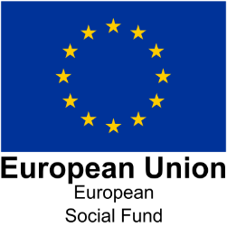

How ESF is making a difference – Employer

Lead provider name | Skills Support for the Workforce  Delivered by Serco Employment, Skills and Enterprise
ESF Contract Number | ESF 5124
Sub-contractor name (if applicable) | The Tess Group  Lisa O’Reilly  lisa@thetessgroup.com  www.thetessgroup.com
Name of business being supported | Project Better Energy  Matt Weightman  0800 1123110  http://www.projectbetterenergy.com/
ESF amount allocated to this business: | £5650
Investment Priority – (to be completed by lead provider)
Local Enterprise Partnership area: | Stoke and Staffordshire
Project start and end date: | LEARNING COURSE DATES (15/1/2020 – 31/7/2020)  Learning is ongoing.  The Skills Support for the Workforce programme runs from April 2019 to July 2021.
Background information:
Overview of the Programme:
Skills Support for the Workforce (SSW) is a programme developed to upskill employees within small and medium-sized enterprises (SMEs) in Stoke and Staffordshire. The programme provides recognised accredited qualifications and bespoke training courses to enhance employees’ skills, increase the competitiveness of businesses and boost the local economy.
The Tess Group is part of Serco’s network of expert organisations chosen to deliver the SSW programme. SSW is co-financed by the European Social Fund and the Education and Skills Funding Agency.
The focus of the Skills Support for the Workforce programme is to:
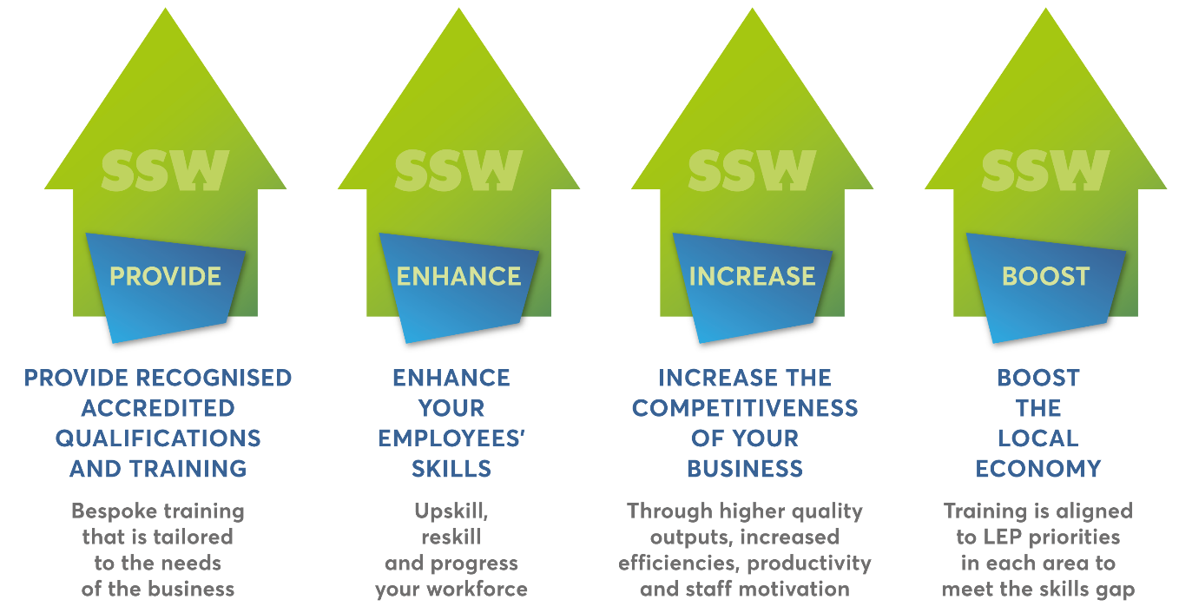
Overview of the Business:
- What is the nature of your business?

The UK's leading business, Project Better Energy are a multi-award winning group of companies specialising in the renewable energy sector. Our mission is to enrich people’s lives and make great things happen. To do this we have established a culture that supports our team members, so they can provide our customer with the highest level of service and provide the broadest range of technology-led products, that will help to enrich their lives, live smarter and save money whilst reduce their energy costs and protecting our planet. Project Better Energy is transforming lives and boosting businesses through state of art technology, setting the standard with industry-leading customer focused service.

In 2018 Project Solar Uk celebrated winning the coveted Company of the Year title at this year’s Derby Telegraph Business Awards. At a glittering awards ceremony Project Solar carried off the title that every business in the county wanted to win.

Project Solar UK Ltd Introducing Better Energy provides free, no-obligation solar advice to help individuals take advantage of tax free incentives. They have helped lots of people find the right solar funding option in the UK. The smart way to use government backed income and energy savings to cover the cost of solar panel system installation.

Other solutions include renewal energy solutions such as batteries and electrical vehicle points.

We met with a previous HR contact Vicky at the end of 2019 to discuss SSW funding availalable and have since developed a strategic relationship with Matt to continue to explore learning and development opportunities. The first group of learners enrolled in January 2020 and due to complete this month (July)

- How many employees do you have?
52

- Are there any challenges that are unique to your business/location/sector?
Energy is a niche sector with challenges in terms of particular business engagement challenges and keeping staff motivated to achieve stretching targets. Attract and retention is a key focus for the business. Location can prove challenging in terms of recruitment.

- What support/training was needed and why?

Management level 3 units were selected for 8 learners with the TNA focusing on the need for developing management skills. The funded units were:

- Manage conflict with a team
- Chair and lead meetings
- Contribute to the improvement of business performance

Topics of focus were needed to develop team members in areas such as:

- Communication skills
- Setting expectations
- Measuring performance / KPIs
- Handling difficult situations and conflict

How has ESF been used to support your business and what impact has this had?
- How did you hear about this provision and how did you think it could help your business?
Meeting with The Tess Group to explain the funding available. We then held a group meeting wvent at the business to share information about courses available.

- How did you decide what training/support would be of benefit the business?
Completion of the TNA and looking through The Tess Group brochure

- Was training needed as a result of – restructure, change in client group, up-skilling, threat of redundancy, or something else?
Up-skilling and development activity

- How many people have benefited from this provision and in what capacity?
8 learners have taken part in the training workshops and 121 coaching sessions

- Which individuals within the business who are willing to share their story?
Yes

- How did the programme meet the needs of the business? Was the provision flexible in terms of timing and location?
The programme met the management development needs and was flexible in terms of offering various dates to have different groups on different dates, working around operational needs.

Outcome and Impact

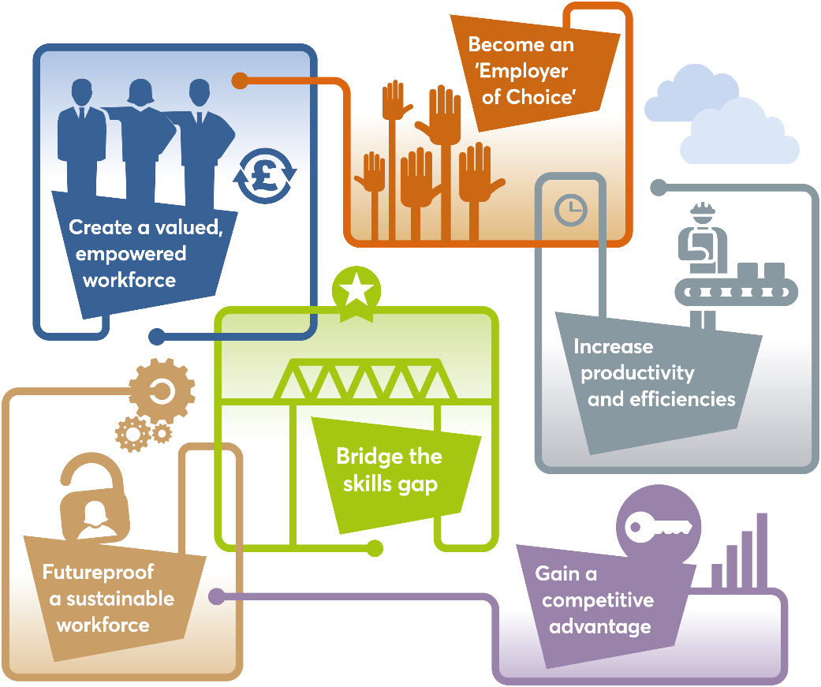

- How many people in the business benefitted from ESF support?
8 learners

- What did they achieve?
Management level 3 units were selected for 8 learners with the TNA focusing on the need for developing management skills. The funded units were:

- Manage conflict with a team
- Chair and lead meetings
- Contribute to the improvement of business performance

Group training workshops took place first, with the follow up of 121 coaching sessions to embed the training. Training has supported to help overcome challenges within the business through improved communication, and toolkits that can be used everyday such as coaching models ILED.

There has been a great knowledge and insight to support learners in their role, this includes day to day operational processes and how to conduct themselves. The training was interactive and split into groups to work around business needs and focus on specific role needs.

121 coaching is now taking place which helps to support learning in place, and how we can apply the communication skills learnt during the current pandemic.

Trainer Andy says: “The learners were highly engaged and took part in group activities. Some activities that went down well were Gaining Commitment, Strategic Alignment theory and Performance Management Checklist”

Trainer Steph says: “Working with the learners to embed what they have learnt and put things in practice has been really rewarding to see the impact of the training”

- What has been the impact in terms of staff morale/customer feedback/productivity?
Team morale has improved as a result of the training workshops and improved productivity.

Matt from PBE says “We want to continue to be an employer of choice and win future awards for our great work in this sector. Training and development helps to keep an empowered workforce and gain a competitive edge”

- Would the business consider further staff development as a result of undertaking ESF training?
Yes we would like to continue to take part in training, with learners already identified to progress onto apprenticeships such as Improvement Practitioner Standard. We have enjoyed working with The Tess Group.

Contact Details for project:
Name:
Website: www.serco-ssw.com
Contact Details :
Date template completed:

Contact Details of ESFA Management and Delivery Team Advisor
Name:
Job title: ESFA Management and Delivery Team Advisor
Email address:

ESF Case Study – Consent Form

ESF Contract Number – ESF 5124

Consent form for European Social Fund case study
Promoting the European Social Fund (ESF)
We (Education & Skills Funding Agency) would like to use your recent experience as an example to tell others about the European Social Fund. We call this a case study or good news story and it is used to show how ESF is helping people to improve their skills and move towards or into employment.

How will my story be used?
- We may use your case study in newsletters, magazines, leaflets or on our website. We would like to use your photograph to accompany your case study wherever possible. Occasionally, we might want to interview you to gather more information.
- We may refer to your case study on a radio station or on TV.
- We may use your case study in local and sometimes national newspapers.
- We may share your case study with the Department for Work and Pensions (DWP) European Social Fund Division (who manage the ESF programme in England) and our partner organisations (Local Enterprise Partnerships) and/or the European Commission to help them publicise ESF using measures described above.
- ESF Division may share your case study with DWP and other Government Ministers who sometimes use case studies when speaking in Parliament or making speeches.

We will share your written case study or press release with you before we start to use it for publicity activity

CONSENT SECTION
Part 1 – For completion by the person either giving or seeking consent
Name of person giving consent: | Matt Weightman  Project Better Energy
Name of ESF provider and contact information (email and/or phone) | Lisa O’Reilly  The Tess Group  lisa@thetessgroup.com  ------------------------------------------  This training provider is part of Serco’s network of expert organisations chosen to deliver the Skills Support for the Workforce Programme – www.serco-ssw.com
Part 2 – Must be completed by person giving consent
We need your consent before we can use your story.

Please tick () the boxes below where you agree to give your consent:
I give my consent for Skills Support for the Workforce and national, local and other ESF partner organisations to use my case study in the following ways: | To use my name | To use my photo
In publicity materials – including booklets, digital media (e.g. websites), feature articles (magazines), radio, TV, local newsletters, exhibition stands, posters etc | Y | Y
In newspaper articles (some articles may also appear on the newspaper’s website) | Y | Y
In Government Ministers’ speeches or in written reports e.g. DWP annual reports | Y | Y

Anonymity: In exceptional circumstances we may be able to use your case study without using your real name, for instance, if there are sensitivities around information you have provided.
However, this would greatly limit the use of your story in the general media and we may not be able to use it at all.

I agree and understand:
I can withdraw my consent to The Tess Group and other organisations using my case study at any time, by contacting Lisa on 01604 210500

- Giving my consent will not affect any benefit I receive, or any future dealings with any Government department or agency.

Signature of person giving consent:

Matt Weightman

Date: 03/7/2020

