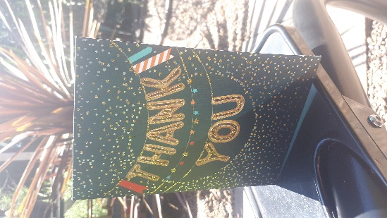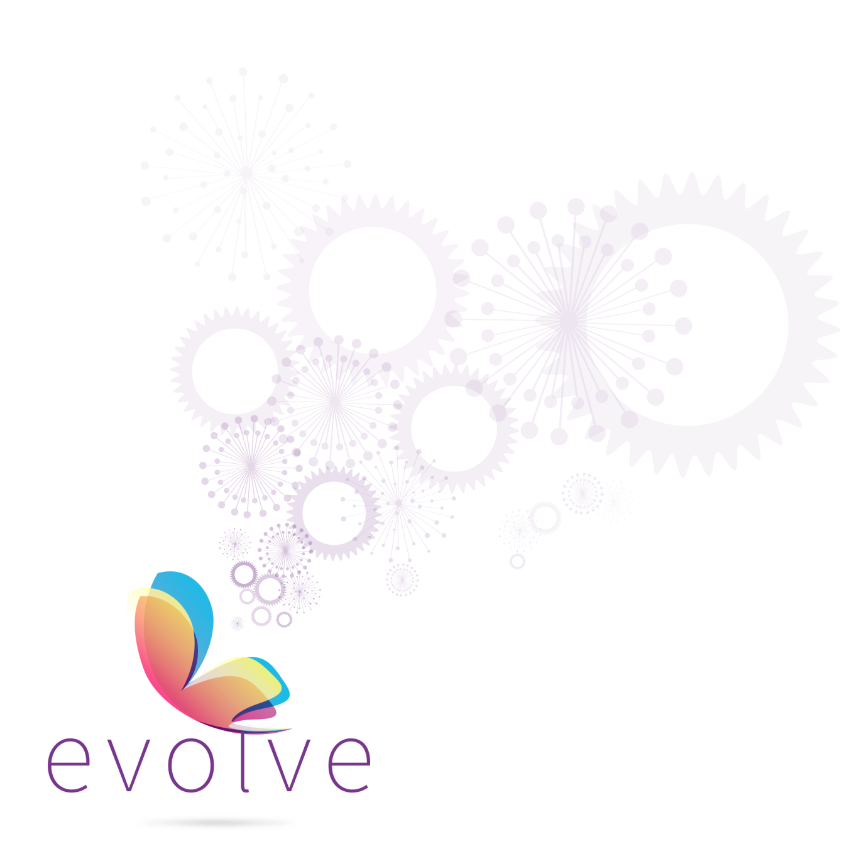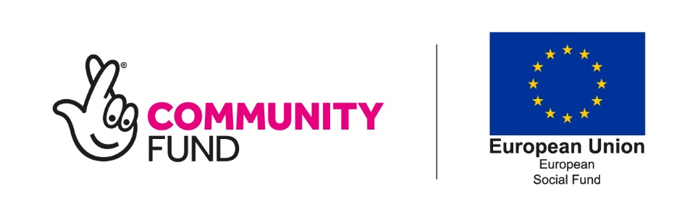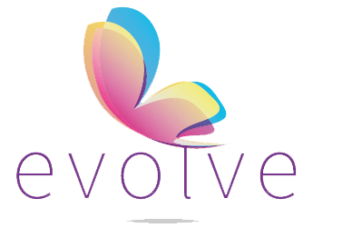-

**Evolve Case Study**

“Huge thanks! You made me believe that I can achieve anything I put my mind to. I feel a great sense of purpose, achievement and independence, I am forever grateful”

When I met Debbie, she had been a stay at home mom for 13 years and had lost confidence in herself. One of her children had special needs and I successfully applied for DLA for him which helped Debbie pay for the adapted clothes, shoes and therapy toys she had to buy. We did lots of activities together including writing a CV, practising interview skills, looking into courses and applying for jobs.

I encouraged Debbie to volunteer with a charity local to her that she was passionate about which improved her confidence and enabled her to have an up to date reference. Debbie left the project when she became economically active, searching for jobs independently and she also completed a Business and Administration level 2, distance learning course.

I had a lovely surprise a few weeks ago when a ‘thank you’ card arrived for me at work from Debbie. The card was full of lovely, positive words and she told me she has started work in an office which she loves! She said that Evolve had really helped to support her and give her confidence and independence. I was absolutely thrilled for her and it was proven to me again how rewarding my job can be.