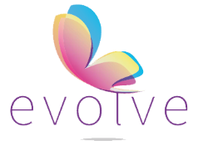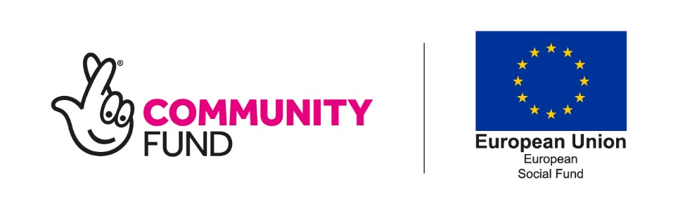

I have received a follow-up call from a former participant who secured employment through the project with a local, family business in Lichfield.

Mark called to say that things were going brilliantly with his new employer, despite the current situation. He is slowly on the journey to full-time work. His days have increased from three per week to four and will increase steadily over time. As previously communicated, Mark was receiving English lessons from a former teacher in the company's accounts department. His English lessons are currently on hold due to the lady working from home.

The employer is encouraging Mark to pass his driving test and will provide him with all of the support he needs to complete this. The benefit to him would be that he can travel between the company's sites. As an incentive for Mark, they have agreed to pay £800 towards the cost of a new bike. Furthermore, they are also willing to help Mark move out of the room he is living in and subsidise a proportion of his rent. Mark will take this offer up in a few months hen he has moved over to a permanent contract with the company.

I wanted to share this follow-up, as it highlights the great work that a local, family-run company are doing to support and develop someone who engaged in our project. The opportunity has given Mark a future and real career prospects. He is receiving unprecedented support, the likes of which many of us would never have expected to see a participant receive, and I am sure we are united in wishing Mark all the best for the future and the opportunity he has seized.

Once again, congratulations, Mark.

Delete & replace with a photo

Delete & replace with a photo

**Evolve Case Study**

“They are amazing Ben. I cannot believe what they are doing to support. Everyone is so supportive and I love working here”.