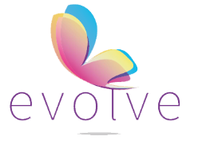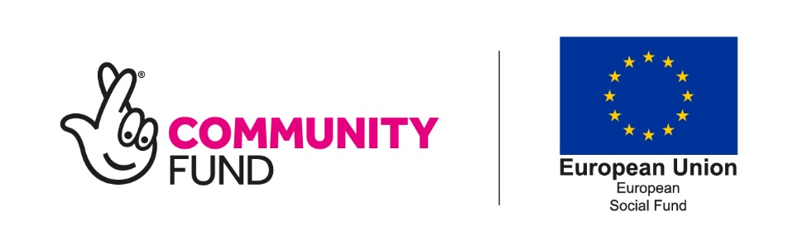

Antony is an active EVOLVE participant.

Just over a month ago I resumed contact with Antony and things had deteriorated. It was very concerning to hear. Ongoing issues with his neighbours meant that he was unable to leave the house resulting in a sudden deterioration in his mental health.

I made a referral to the community mental health team and agreed with Antony that I will work with him twice to three times weekly to improve his self-esteem and overall wellbeing until the mental health team take over.

During our calls we would discuss everything that is going on and share our experiences, both good and bad, showing Antony that during the lockdown, everybody, to some degree, has had some form mental health decline. We spoke about how we can turn our problems into solutions and changing the way you think. We also tied in project activities in a more relaxed way, focusing on improving his wellbeing.

I am pleased to say that during our review today, his distance travelled scores across the board, especially confidence, self-esteem, and wellbeing have increased by seven points. Antony is feeling on top of the world, and I am elated with the improvement he has made in such a short space of time.

This shows the impact our calls are having to those whom may be struggling but not openly disclosing. The feeling you get knowing that you have brought someone up who was not eating for days was unexplainable and I am so proud of the progress he has made, mentally.

Keep it going!

**Evolve Case Study**

“I can now see the light at the end of the tunnel. Everything seems to be falling into place and creating solutions from my problems”.