STOKE ON TRENT & STAFFORDSHIRE
LOCAL ENTERPRISE PARTNERSHIP
COMPANY EXECUTIVE BOARD MEETING
19 December 2019

Item 11: Update report on the Stoke-on-Trent and Staffordshire LEP’s ESIF Programme

Background

The European Structural Investment Funds (ESIF) Programme launched in March 2015 and since this time has, on behalf of the LEP, delivered a wide range on activity across the LEP’s geography.

Directors will recall that the ESIF Programme is made up of three funding stream’s, these along with the LEP’s allocation are highlighted in the table below. As a Transition Area Stoke-on-Trent and Staffordshire have a higher intervention rate of up to 60% across these three programmes. The following section takes each of the three funding streams in turn and provides an update as to its allocation and delivery.

ESIF Programme | Themes for Investment | LEP Allocation
European Regional Development Fund (ERDF) | Innovation, ICT, Business Support, Low Carbon, Flooding and Biodiversity | £90.85M
European Social Fund (ESF) | Access to Employment, Sustainable Integration of Young People, Active Inclusion, Skills for Growth, Improving the Market Relevance of Education | £65.5M
European Agriculture Fund for Rural Development (EAFRD) | Rural Enterprise, Tourism, Food Sector | £3.12M

European Regional Development Fund (ERDF)

ERDF forms the largest element of the programme with £90M of EU funds available over the life of the programme. As with all three funding streams they are managed through a National Programme which guides on eligibility, and project management to ensure the successful delivery of the programme. Under ERDF there are a number of “Themes” which the funding can support. At the outset of the ERDF programme the total LEP allocation was split and fixed into these themes, these are as follows,

ERDF Theme | Notional Allocation | Allocated to Projects
Innovation | £25.17M | £24.84
Broadband and ICT | £0.53M | £.50M
Business Support | £46.14M | £39.97M
Low Carbon | £15.01M | £14.50
Flood Mitigation | £0.94M | £0.94
Biodiversity | £3.06M | £2.75M
Total | £90.84M | £83.50M

The ERDF Programme, following a final round of calls for Projects in the Autumn, has been able to allocate £83.5M to Stoke-on-Trent and Staffordshire Projects, a summary of these are contained in Annex 1. This equates to 92% of the LEP’s ERDF programme with a residual amount of £7.34M being returned to a National Reserve Fund. A further breakdown of the ERDF commitment to projects is highlighted in the table below.

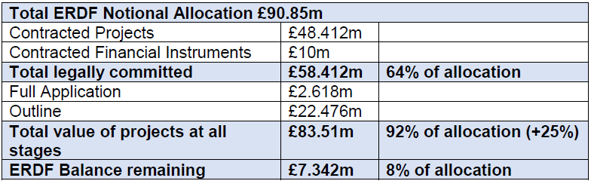

In comparison with other UK LEP’s which cover Transition Areas, like that of Stoke-on-Trent and Staffordshire, the national average for ERDF committed is 70%, whilst here in Staffordshire we have achieved 92% allocation of our ERDF award.

National Reserve Fund

As noted in the above table SSLEP were unable to allocate 100% of the ERDF Programme funds. The residual £7.34M has now been returned to Treasury, however further national calls for projects are anticipated around April/May 2020. It is therefore important that the technical assistance team, who oversee the programme delivery at the local level, continue to promote this opportunity, and then work with any prospective applicants once projects are identified.

Output Delivery

Each of the projects which are successful of progressing through the two stage appraisal process has to contract with the Department of Housing, Communities and Local Government, who manage the overall programme, confirming the outputs that the specific project will deliver. Each of the Themes has within it a Key Output, and the SSLEP programme as a whole has output targets to meet. The table below identifies the programme targets and the estimated total, based upon contracted and pipeline outputs. As can be seen from the table four themes are likely to vastly exceed their targets, one is likely to fall just short and one is going to seriously underperform. **(On the underperforming output the Managing Authority acknowledge that redundant land currently in a flood plain will be brought back into use rather than relieving existing businesses from flood risk)

Theme Key Output | Target | Total | Variance
Innovation – enterprises receiving support | 712 | 1316 | +604
Broadband & ICT – enterprises receiving support | 101 | 500 | +398
Business Support – enterprises receiving support | 4065 | 3831 | -234
Low Carbon – Reduction in tonnes of Co2 | 6577 | 44660 | +38082
Flood Mitigation – Commercial properties with reduced flood risk | 107 | 6 | -107**
Biodiversity – Hec with improved conservation status | 53 | 135 | +82

Although the key output for each theme aims to measure performance, clearly projects have within them a broader range of outputs which are delivered as a result of the specific project being implemented. Members may be aware that the output regime for ERDF is stringent in comparison to other programmes, for example, for a business assist to be captured 12 hours of support have to be delivered to that business. This results in a large number of potential outputs not being recorded.

A few highlights from the table below, it is predicted that the ERDF programme will have resulted in £14.5m of private sector investment being made, this is companies investing in their own business facilitating growth or innovation. The programme will enable Stoke-on-Trent and Staffordshire companies to bring nearly 200 new products to market alongside close to 600 who will have been able to work with higher education and research establishments both within and outside of our LEP area. Finally the programme has delivered close to 300 start-up businesses to date and will deliver close to 1500 direct jobs upon its conclusion.

Outputs | Programme Target | Delivered (Sept 19) | Percentage Delivered
Enterprises receiving Grants | 841 | 407 | 48%
Enterprises Working with Research | 594 | 205 | 35%
New products to market | 146 | 99 | 68%
New to firm products | 187 | 129 | 69%
GHG Reductions | 6657 | 577 | 8%
Enterprises supported non financially | 1819 | 1100 | 61%
New enterprises supported | 466 | 360 | 77%
Private Investment (match | £14,513,716 | £6,456,522 | 44%
New Employment | 1428 | 657 | 46%
No of start-ups enterprise ready | 174 | 285 | 164%
enterprises receiving brokerage | 1020 | 502 | 49%

Summary

Based upon the current status of the ERDF Programme it is considered that the Programme has performed well. It has supported strategically significant projects within the LEP area in addition to promoting innovation alongside mainstream business support activities. The task moving forward is to continue to ensure that the ERDF Programme fully delivers on its spend and outputs in addition to ensuring that the SSLEP area takes advantage of any funds that become available through the National Reserve Fund

European Social Fund

The SSLEP’s European Social Fund Programme was launched in 2014 and is built primarily on a co-financing model. With limited local public sector resource for employment and skills activity it was decided early in the programme that the offers of the requisite 40% match funding from National organisations would be seized.

The Department of Work and Pensions, The Education and Skills Funding Agency along with The National Lottery (formerly the Big Lottery) all offered to provide the match funding both to maximise their own investment value and the broaden out their scope in terms of activity.

SSLEP decided to opt-in with all 3 organisations and worked with them to produce the specifications for the programmes across the investment priorities. This resulted in £37M of SSLEP’s ESF funding being allocated in the first round of programmes. SSLEP funds were supplemented by £6.6M from the allocation given to GBSLEP for the four districts of Cannock, Tamworth, Lichfield and East Staffordshire) who are also in GBSLEP area.

ESF programmes are split into 2 priority areas. Priority 1 focuses on individuals who are unemployed or economically inactive, including supporting the integration of young people and those furthest from the labour market with support around social inclusion. SSLEP developed a pathway model to help people engage with the programmes at a point relevant to their skills and employment requirements, the principle being that there was no wrong door for participants, and that they would be directed to the most appropriate programme for them.

Priority 2 focuses on those in employment to upskill or retrain. Businesses have been supported to identify skills needs within their organisation, with the programmes then allowing them to upskill and/or retrain their workforce.

Investment Priority | Euro Allocation | £ Allocation | £ Committed | Potential Commitment
1.1 Unemployed and Economically Inactive | 23,209,275 | 20,192,069 | 20,192,069 | 0
1.2 NEET’s | 11,460,159 | 9,970,338 | 9,970,338 | 0
1.4 Active Inclusion | 13,911,573 | 12,103,069 | 12,103,069 | 0
PA1 Total | 48,581,007 | 42,265,476 | 42,265,476 | 0
2.1 Access to Lifelong Learning | 22,656,372 | 19,711,043 | 16,302,222 | 3,408,224
2.2 Improving Relevance of Education | 4,037,746 | 3,512,839 | 1,626,076 | 1,886,000
PA2 Total | 26,694,118 | 23,223,883 | 17,928,298 | 5,294,224
TOTAL | 75,275,125 | 65,489,359 | 60,193,774 | 5,294,224

The majority of the opt-in programmes have been successful in terms of outputs as can be seen below. Progressions under each of the funding priorities will include the following:

Progression into Employment
Progression into Volunteering (not included in the new contracts)
Progression into Education
Progression into Apprenticeship
Progression into Traineeships

Original Contracts  2016 - 2019 | Starts Actual | Starts Target | % Delivered | Progressions Actual | Progressions Target | Percentage Delivered
1.1 | 5598 | 5941 | 94% | 3665 | 1388 | 273%
1.2 | 4144 | 3852 | 108% | 2412 | 1776 | 139%
1.4 | 3769 | 4237 | 89% | 1165 | 1968 | 59%
2.1 | 6773 | 7952 | 85% | 3703 | 6656 | 55%
Totals | 20284 | 21982 | 92% | 10945 | 11788 | 92%
New Contracts  April – Oct 2019 | Starts Actual | Starts Target | % Delivered | Progressions Actual | Progressions Target | Percentage Delivered
1.1 | 1219 | 2077 | 59% | 366 | 1039 | 35%
1.2 | 899 | 2857 | 31% | 368 | 1543 | 24%
1.4 | 83 | 638 | 13% | 0 | 202 | 0%
2.1 | 1007 | 2449 | 41% | 310 | 979 | 32%
Totals | 3208 | 8021 | 38% | 1044 | 3763 | 27%

In summary this includes

ESF Programme Outputs: Total to Sept
Learners | 18190
Progression into work | 919
Progression within Work | 5249
Apprenticeships | 260

The impact of the ESF programmes on local skills can be seen in qualification level data graphs for 16-64 year olds on NOMIS, which clearly shows the growth in qualified SSLEP residents since 2014/2015. By 2018, the gap had been closed to be just below national averages, although certain parts of the LEP remain several percentage points adrift.

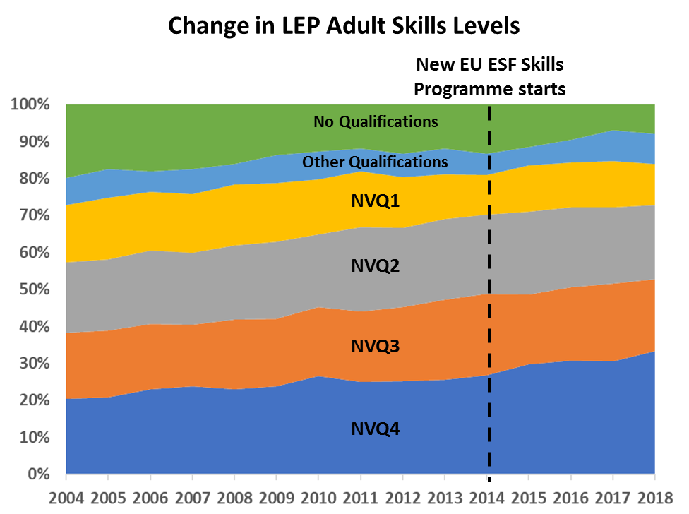

Alongside the opt-in programmes, the Managing Authority (DWP) has also published two Open Calls for SSLEP. After a protracted period of appraisal, the first project, the Skills Hub, was awarded in 2019. The second open call, addressing Higher Level Skills requirements is still in appraisal.

The Managing Authority have recently published two further linked Open Calls on behalf of the LEP (December 2019) under Priority 2 which will look to focus on employer engagement with schools, colleges and training providers around the provision of high quality Careers Information, Advice and Guidance and the design and delivery of the curriculum. The combined value of the two published linked calls will be £3.9M.

The remaining ESF unallocated funds, and any identified underspend have now been returned to a Central Reserve Fund, to which SSLEP will be able to bid to have Open Calls.

European Agricultural Fund for Rural Development (EAFRD)

EAFRD is the smallest of the ESIF funds and is the most specific in what projects and activities it can be used to support. £3.12m was the original allocation to the SSLEP area and funding is available to directly support rural businesses under the Food Processing, Tourism Infrastructure themes and a more general Business Development theme. These all support companies situated in rural locations and rural key towns across a range of business sectors. The total allocation and committed funding across these themes is summarised in the following table.

EAFRD Theme | Notional Allocation | Allocated to Projects
Business Development | £0.33M | £0.17M
Food & Drink Processing | £1.12M | £0.21M
Tourism Infrastructure | £1.67M | £2.30M
Total | £3.12M | £2.68M

The last and final EAFRD call closed in June 2018. At that point the EAFRD allocation was to be committed in full but the withdrawal of three rural business projects has meant that £0.44m will be returned to the EAFRD National Reserve Fund which is currently open for new applications. A more detailed breakdown of the EAFRD commitment to projects is highlighted below.

EAFRD allocation £3.12M
Completed & Contracted | £0.88M | 8 projects
Commitment breakdown
Exp. Of Interest (EOis) | £0.00M
Full application | £1.80M | 2 projects
Total EAFRD at all stages | £2.68M | 10 projects
EAFRD balance remaining | £0.44M

EAFRD National Reserve Fund

The EAFRD National Reserve Fund is the first of the ESIF funds to commit remaining allocations from all of the eligible LEP. The National Reserve Fund value stands at around £30m but managing authority DEFRA has indicated if the demand for funding is high then as much as £50m could available to allocate. The call opened on 5th November 2019 and will close to applications on 16th February 2020. All three EAFRD themes are available to bid against and promotion of this call is being made through the LEP and Growth Hub networks. In addition a workshop and project surgery is being held at Rodbaston College on 16th December and interested rural businesses and partners are being invited to receive support and advice on any bid ideas.

EAFRD Output Delivery

EAFRD outputs are not reported in the same detail as the other ESIF funds but the projects already contracted and those likely to be contracted will create new employment, support rural businesses and increase visitor numbers which will all boost the rural economy across the SSLEP area.

Author: Mark Connell; Strategic Funding & Partnerships Manager, Stoke on Trent Council mark.connell@stoke.gov.uk

