**Local Skills Report**

**Annex A – Core indicators**

**Local Landscape**

**Local Landscape - Summary**

* Overall, Stoke-on-Trent and Staffordshire has seen strong recent jobs growth, business creation, record low unemployment and the size of the economy grow.
* The area has a more balanced and resilient economy with growth in professional and service-based industries alongside our existing strong manufacturing base. The LIS and SEP set out clear ambitions for growth with local priority sectors including advanced manufacturing, modern methods of construction and advanced logistics. Cutting across all of our key sectors we recognise the importance of digital and the adoption of new technologies alongside the green economy and the transition to net zero.
* Clearly the drive for highly productive clean growth requires the development of skills in order for our residents to be able to access the higher value, higher skilled and better paid occupations in new areas of the economy.
* COVID-19 has accelerated the adoption of new digital technologies such as automation, AI and machine learning across all sectors. Digital skills development will be vital to supporting this transition and making the most of the opportunities that technological advancement provide to the economy in Stoke-on-Trent and Staffordshire.
* Beyond our local priority sectors for growth and productivity, we also recognise the growing demand from our health and social care sector due to the ageing population and more recently COVID-19. The sector has seen by far the highest demand for labour and skills during the pandemic and there exist a number of skills gaps currently such as within nursing and social care workers. Given the ongoing demand due to the pandemic and the ageing population this sector presents an opportunity for those that have found themselves out of work during the crisis to upskills and retrain into areas of high demand.
* The SAP will work closely with new and existing businesses and providers to ensure that the skills supply matches the changing demands within our local economy. We will provide the support necessary for businesses to thrive and flourish in Stoke-on-Trent and Staffordshire helping to further grow the economy and increase prosperity within our communities.
* We will also look to ensure that everyone has the opportunities to achieve their ambitions, this is even more important due to the damaging effect that COVID-19 has had on the economy. We will ensure that no one is left behind due to where they live or a lack of skills and that everyone can place an active part in growing the local economy which leads to a better quality of life for all.

**Employment by sector:**

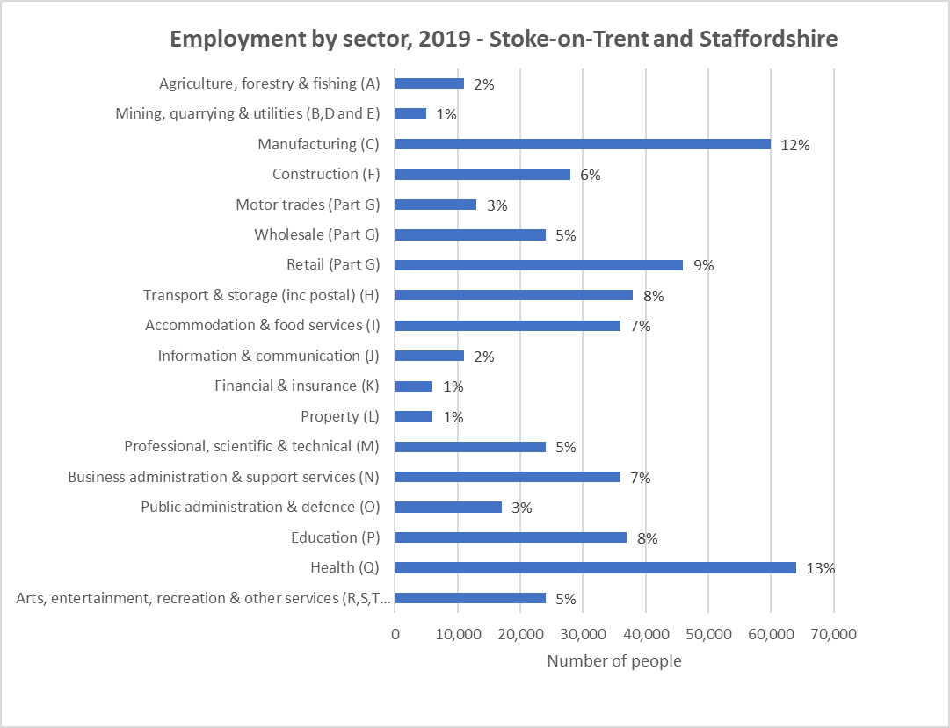

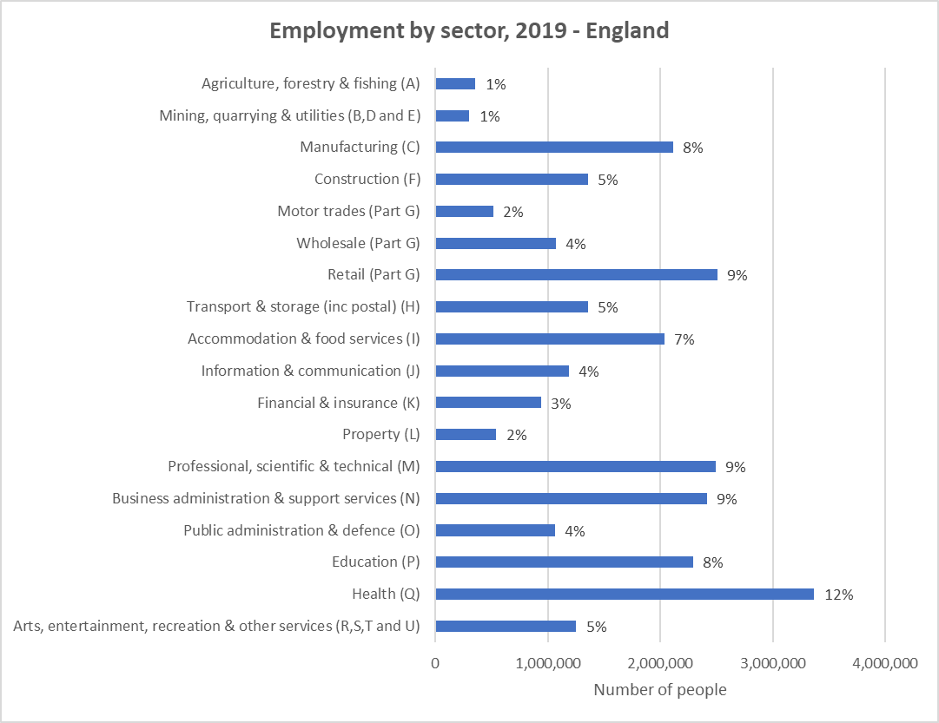

***Source:***[*Business Register and Employment Survey, 2019 (published 2020), 2020 SAP boundaries*](https://www.nomisweb.co.uk/datasets/newbres6pub)

Stoke-on-Trent and Staffordshire has seen a shift in jobs recently helping to create a more balanced and resilient economy with growth in services alongside continued strengthening within our strong manufacturing base.

The largest sector of employment is wholesale and retail including motor trade with 83,000 jobs which make up 17% of all jobs in Stoke-on-Trent and Staffordshire, this is a slightly higher concentration of jobs than seen nationally (15%). Clearly, this sector is important in all areas but has experienced significant impact from the COVID-19 pandemic with health restriction measures and national lockdowns causing large swathes of businesses in the sector to have to either reduce operations for long periods or close entirely. At the same time COVID-19 has accelerated the consumer channel shift to online retail meaning that many bricks and mortar premises have seen reduced demand during the crisis. This has meant that there are also changes in labour and skills demands from the sector with increasing demand for digital and IT skills alongside growth in support for online retail from the logistics sector.

Stoke-on-Trent and Staffordshire already has a strong concentration of jobs in logistics with 38,000 jobs representing 8% of all jobs well above the national average of 5%. Our Local Industrial Strategy (LIS) recognises the importance of this sector and we see a number of growth opportunities including our central location and strong connectivity, available land and premises to support growth, Covid-19 has accelerated the shift to online retail with increasing demand for warehousing and wider supply chain logistics, and new digital technologies such as automation and AI are driving growth in highly productive advanced logistics.

Health and social care accounts for the second largest number of jobs with 64,000 or 13% of all jobs in Stoke-on-Trent and Staffordshire, which is in-line with the national average. Again, this sector is clearly important across the country and has been on the frontline in the battle against COVID-19. Health and social care has seen by far the strongest demand for labour during the crisis and we expect this to continue given that we were experiencing skills gaps, such as nursing and social care workers, prior to COVID-19 and the increasing demand for health and social care from the ageing population.

Manufacturing is a clear sector strength in Stoke-on-Trent and Staffordshire with 60,000 jobs representing 12% of the entire workforce, which is a far higher concentration of jobs than the national average of 8%. As with previous recessions, COVID-19 has caused significant disruption within the manufacturing sector with imports and exports badly affected, a decline in demand impacting on turnover, cash flow and cash reserves, alongside many workers having to be furloughed or in some cases made redundant. Although manufacturing is likely to continue to see some negative impacts from the ongoing crisis and Brexit we recognise that there are also opportunities for growth within the sector including the adoption of new digital technologies driving growth in highly productive advanced manufacturing including automation, AI and machine learning, new international markets, reshoring due to COVID, and the Green Economy transition to net zero.

Stoke-on-Trent and Staffordshire also has a higher concentration of jobs in construction that seen nationally, with 28,000 jobs representing 6% of the workforce compared to 5% nationally. We see construction as a local priority sector due to the wide range of growth opportunities including new digital technologies driving growth in Modern Methods of Construction including offsite construction, automation & AI, Government house building targets through local plans, major infrastructure, transport and energy projects such as HS2 and West Midlands Freight Interchange, and the Green Economy including environmentally sustainable construction, retrofitting and renewable energy.

Clearly, new digital technologies such as automation and AI alongside making the most of big data are now becoming increasingly prominent in all parts of the economy and society (connectivity), where even in the midst of the COVID-19 recession there are some 90,000 new digital job vacancies a week nationally. We recognise digital as a cross-cutting priority area to help drive growth and productivity across our local economy and have embedded digital skills development within the LIS and our supporting local economic and skills strategies.

**Employment by occupation:**

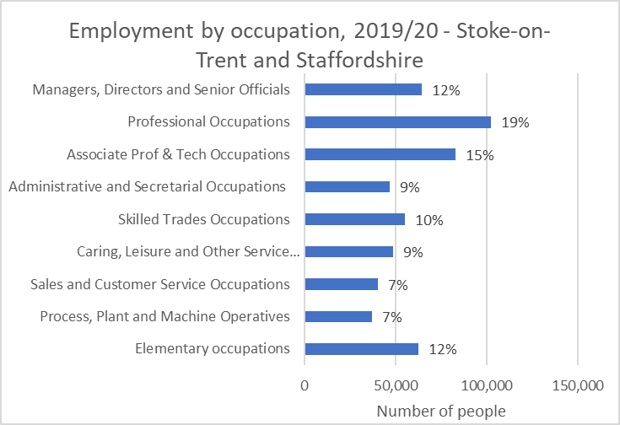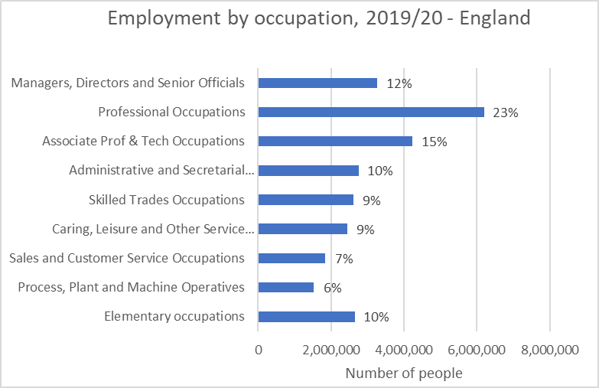

***Source:*** [*Annual Population Survey, October 2019 - September 2020, 2020 SAP boundaries*](https://www.nomisweb.co.uk/datasets/apsnew)

The main occupations of employment in Stoke-on-Trent and Staffordshire are ‘Professional Occupations’ accounting for nearly of fifth (19%) of the workforce, ‘Associate Professional and Technical Occupations’ (15%) and ‘Managers, Directors and senior Officials’ and ‘Elementary Occupations’ (both with 12%).

Overall, the occupational profile of Stoke-on-Trent and Staffordshire is similar to the profile seen nationally, however there are several important nuances. Stoke-on-Trent has a lower proportion of jobs in the ‘top 3 occupational groups’ partly reflecting our industrial heritage but there has been an increase in higher occupations over recent years as skills levels have improved and service-based industries have grown. At the same time the area continues to have a higher concentration of jobs in ‘Skilled Trades Occupations’ and ‘Process, Plant and Machine Operatives’ reflecting the strong manufacturing base in the area.

Our LIS sets out a clear ambition to grow the economy and increase productivity with continued skills improvement and the creation of higher skilled, higher valued and higher paid jobs within our priority sectors central to this ambition.

It is too early to say what the full impact of COVID-19 will be on the economy, but it is clear that the pandemic has accelerated the adoption of new digital technologies across all sectors and this is likely to be a key driver of occupational change during the recovery. Prior to the crisis manufacturing jobs and elementary roles within sectors such as logistics were projected to decline due to the move to new technologies such as automation, AI and machine learning with this trend expected to accelerate due to the impact of COVID-19. Digital skills development will be vital to supporting this transition and making the most of the opportunities that technological advancement provide to the economy in Stoke-on-Trent and Staffordshire.

**Enterprises by employment size band:**

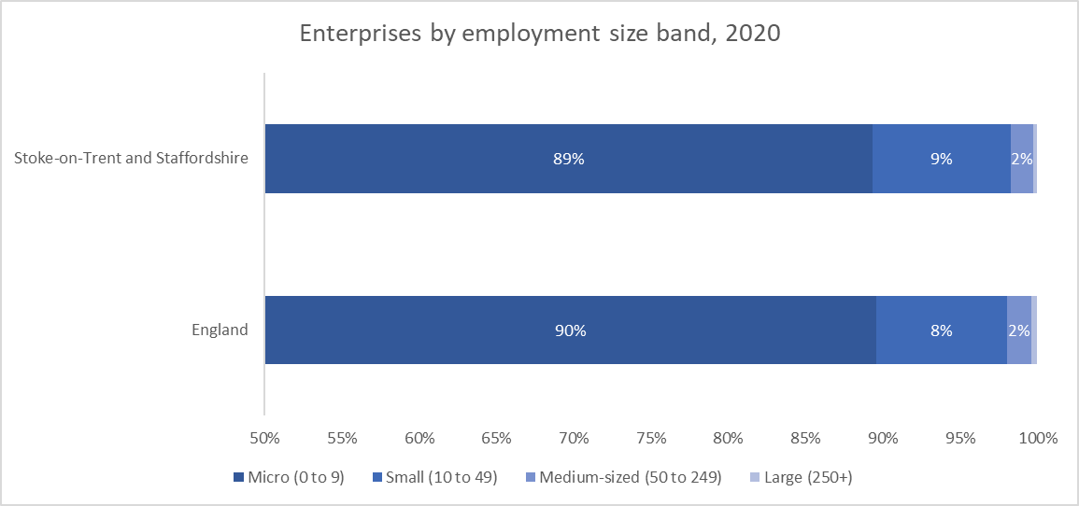

***Source:*** [*UK Business Counts, 2020, 2020 SAP boundaries*](https://www.nomisweb.co.uk/sources/ukbc)

The local business landscape in Stoke-on-Trent and Staffordshire is predominately made up of SMEs which represent over 99% of all businesses and 77% of jobs, the business profile is very similar to the national picture. We continue to see growth in our business population with more and more businesses choosing Stoke-on-Trent and Staffordshire to do business, as expected the main growth is within micro businesses where entrepreneurs are supported to start-up their own businesses. At the same time, we have also continued to see growth in large businesses, which account for 23% of all jobs, with our local offer continuing to be successful in attracting new inward investment and our effective business support helping existing businesses to grow.

The sectors with the largest business populations are ‘Wholesale and retail’ (6,055 businesses), ‘Construction’ (5,805) and ‘Professional, scientific and technical activities’ (5,215). The main sectors in which we are seeing business growth are ‘Professional, scientific and technical activities’, ‘transportation and storage’ and ‘construction’ with the expectation that these areas will continue to see growth as we recover from COVID-19.

At the local authority level, Stoke-on-Trent, East Staffordshire, South Staffordshire and Tamworth are the areas which are seeing the highest rates of growth. Although all of our local authorities have seen growth rates below those seen regionally and nationally. To further increase business growth in Stoke-on-Trent and Staffordshire there continues to be significant investment in services including business support, inward investment, skills development and bringing forward land and premises with local planning authorities.

The SAP has a key role in ensuring that businesses of all size have a voice in strategic decision making and allocations of funding to improve the local economic landscape. The SAP continues to develop stronger partnership working with local businesses of all sizes and strives to engage with our businesses at every opportunity be it through existing business networks such as the Chamber of Commerce, increased business membership on the SAP Board or conducting extensive representative consultations to understand the needs of our businesses.

**Business birth and death rates:**

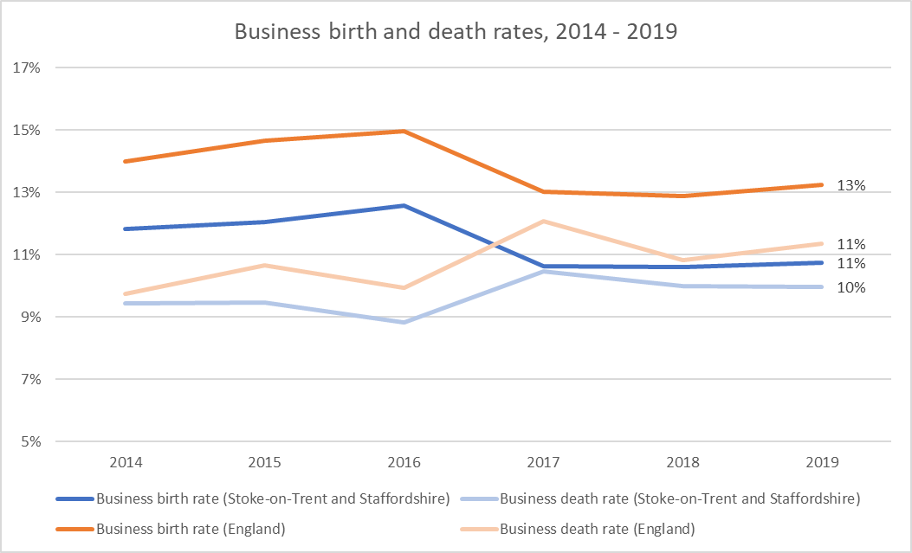

***Source:*** [*ONS Business Demography, 2014 - 2019 (published 2019), 2020 SAP boundaries*](https://www.ons.gov.uk/businessindustryandtrade/business/activitysizeandlocation/datasets/businessdemographyreferencetable)

The rate of business births and deaths in Stoke-on-Trent and Staffordshire have followed a similar trend to what has been seen nationally. Business births have plateaued following over the last couple of years following a slight dip which is partially as result of the significant increase in business births that followed the financial crisis and resulting economic downturn starting to slow. At the same time business deaths have also plateaued following a slight increase, again this reflects the increasing competition in an increasingly strong economy.

Although the general trends of business births and deaths in Stoke-on-Trent and Staffordshire have followed those witnessed nationally, we have generally seen lower rates of business start-ups and at the same time lower rates of business failure. As with previous recessions, there is likely to be an increase in entrepreneurialism due to the impact of COVID on the availability of jobs, with a number of those that have found themselves out of work choosing to start their own business.

Our COVID-19 recovery strategy has a clear ambition to support entrepreneurs that wish to start-up a local business; however, we also want to ensure that as many of these businesses are viable in the long-term and sustainable. This follows our successful business support work such as through the Stoke-on-Trent and Staffordshire Growth Hub which has seen Stoke-on-Trent and Staffordshire business survival rates outperform those seen nationally for many years now.

**Employment rate and level:**

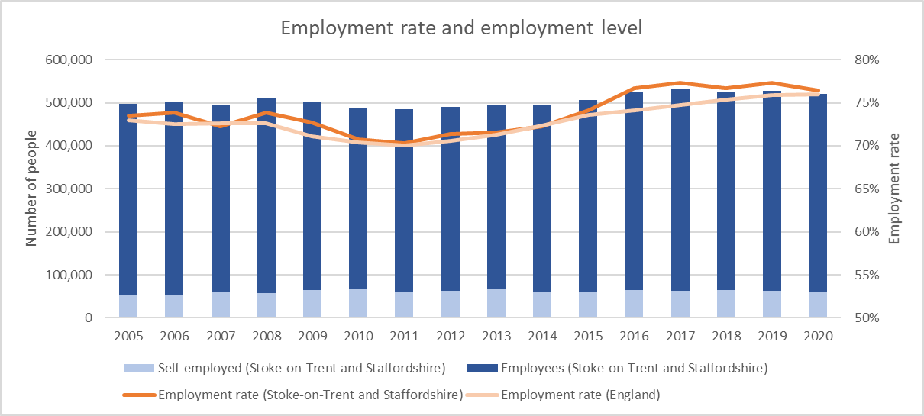

***Source:*** [*Annual Population Survey, 2005 - 2020, 2020 SAP boundaries*](https://www.nomisweb.co.uk/datasets/apsnew)

The employment rate in Stoke-on-Trent and Staffordshire has been rapidly increasing since the financial crisis and resulting economic downturn and currently stands at 76% which is well above the levels seen prior to the financial crisis and is in-line with the national average. However, the rate in Stoke-on-Trent and Staffordshire declined from 77% in 2019 to 76% in 2020, which was the first decline since 2011 and reflects the early impact of COVID-19.

There is significantly wide variation in the rate of employment at the local authority level, with Cannock Chase having the highest employment rate in 2020 at 85% compared to Newcastle-under-Lyme with 71%. Clearly there will be a number of reasons for this variation including the availability of jobs which match the local labour pool, workforce skills, accessibility to work, the health of the local population etc.

Currently the self-employed account for 9% of the workforce in Stoke-on-Trent and Staffordshire which is slightly lower than the national average of 10%. As previously discussed, the reason for this is that we generally have lower levels of entrepreneurialism but for those that do choose to start-up their own business we have better business survival rates. We anticipate that as was seen following the financial crisis, COVID-19 is likely to lead to an increase in self-employment as people that have lost their job choose to start-up their own business and we are putting extensive and strengthened support in place to make sure as many as possible are a success.

Around a fifth of the working age population are economically inactive which is lower than the level seen nationally (21%). The main reasons for being economically inactive are long-term sickness (32%), being a student (21%), retired (20%) and looking after family or home (19%). Of those that are economically inactive more than three quarters (77%) do not want a job, while 23% do want a job accounting for 30,100 workless residents.

Clearly COVID-19 has had a significant impact on employment levels across the country, but it is too early to say what the full impact will be. In Stoke-on-Trent and Staffordshire, we have seen substantial increases in Universal Credit Claimants, Furloughed workers and Self-employment Income Support claims alongside this we continue to hear of more HR1 redundancy notifications. The main concern regarding employment levels is what happens once Government support is withdrawn such as the planned end to furlough at the end of March, many commentators feel that it is likely that we will see a further significant spike in unemployment.

The need now is to ensure that our residents that may find themselves out of work have the skills and support in place to either find new employment or start-up their own business.

**Nominal GVA per hour worked:**

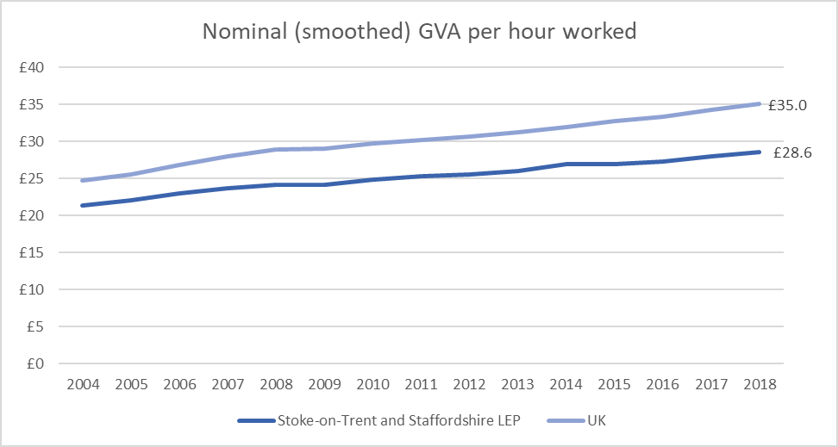

***Source:*** [*ONS Sub regional Productivity, 2004 - 2018 (published 2020), 2018 LEP/MCA boundaries*](https://www.ons.gov.uk/employmentandlabourmarket/peopleinwork/labourproductivity/articles/regionalandsubregionalproductivityintheuk/february2020/relateddata)

Productivity levels in Stoke-on-Trent and Staffordshire have improved over time, however the increase in productivity has been at a slower rate than seen nationally meaning that the productivity gap to the national average has widened.

Wage levels provide an indication of why productivity growth has lagged behind the average growth seen nationally, with workplace earnings growing at a slower rate than the national average indicating the presence of more lower value roles. More positively resident earnings have seen faster growth than on average which is partly due to a number of our residents travelling out of the area to work in higher value better paid jobs. Given that the cost of living and wages are comparatively lower in Stoke-on-Trent and Staffordshire it make the area attractive to both people wanting to live in a rural, attractive shire and at the same time businesses wanting to access a competitively priced skilled labour pool in a well-connected location.

Our LIS has a clear ambition to grow the economy by driving improvement in productivity, by creating the right environment for businesses to start up and grow alongside ensuring that we have a highly skilled workforce to support growth.

As with many areas of the country ‘Wholesale and retail’ (14% of total GVA) and ‘Health and social care’ (10%) are sectors which significantly contribute to GVA in Stoke-on-Trent and Staffordshire. However, unlike many other areas our strong manufacturing base is also a major strength when it comes to generating GVA (14%). We also have a larger concentration of jobs in the construction industry leading the sector also being a key contributor to GVA (8%).

**Median gross weekly wage for full-time workers:**

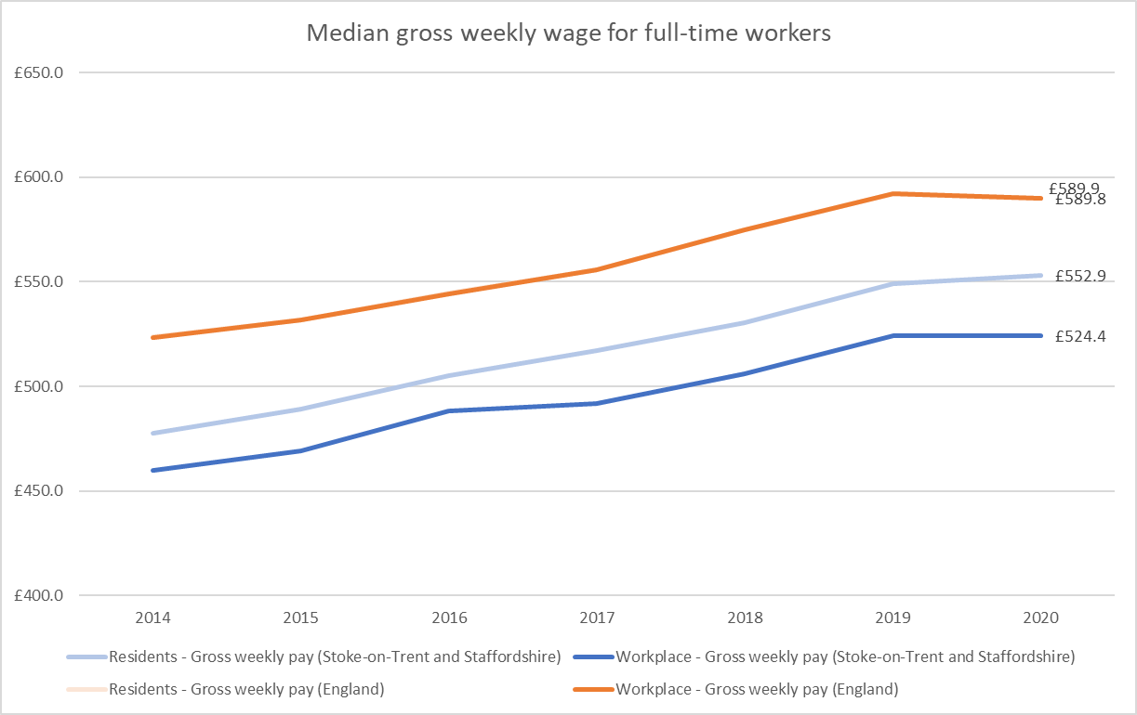

***Source:*** [*Annual Survey of Hours and Earnings, 2014 - 2020, 2019 LEP boundaries*](https://www.nomisweb.co.uk/sources/ashe)

In Stoke-on-Trent and Staffordshire resident earnings are generally higher than workplace earnings, but for both resident and workplace earnings the area lags behind the national average. As previously discussed, workplace earnings in Stoke-on-Trent and Staffordshire have grown at a slower rate than nationally while the opposite is true of resident earnings. This indicates that there is a larger presence of lower paid roles in Stoke-on-Trent and Staffordshire than on average, which is partly a reflection of the industrial heritage of the area. At the same time travel to work patterns show that many residents travel out of the area to work in higher value, better paid jobs such as in Birmingham and Manchester.

While ideally, we would want to see increased self-containment where residents live and work in the area, the fact that some residents do travel out of the area to work and then bring money back into the area is not a significant concern. One of the main issues that this does raise is do we have a strong enough labour pool with the skills necessary to support growth in high value sectors that generate better skilled and better paid jobs alongside this out-commuting. A key aim of the SAP is to raise skill levels across the board so that our area becomes increasingly attractive to inward investors in higher value industries leading to stronger economic growth, improved productivity and greater prosperity for our residents.

At the local authority level there are variations in wage levels where for resident earnings Lichfield and South Staffordshire have the highest wages, while Stoke-on-Trent and Newcastle-under-Lyme have the lowest. For workplace earnings Staffordshire Moorlands and Stafford have the highest levels compared to Tamworth and Newcastle-under-Lyme which have the lowest.

**Population by age group:**

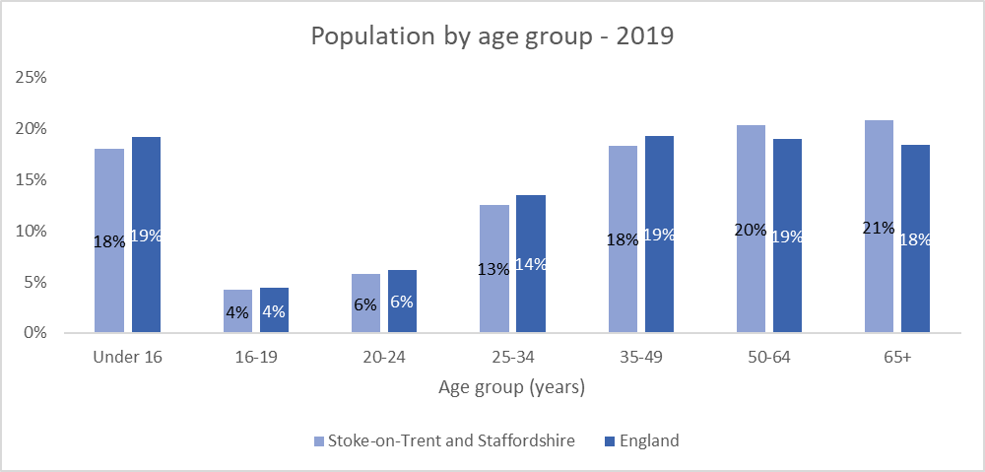

***Source:***[*ONS Mid-Year Population Estimates, 2019, 2020 SAP boundaries*](https://www.ons.gov.uk/peoplepopulationandcommunity/populationandmigration/populationestimates/datasets/populationestimatesforukenglandandwalesscotlandandnorthernireland)

The population of Stoke-on-Trent and Staffordshire is growing, with an increase of nearly 50,000 over the last decade. The age profile in the area is that of an ageing one, with those aged 65+ increasing by 48,800 over the last decade. During this period the working age population, particularly those of a younger age (18-24), has been declining with a decrease of 5,600. While those aged 0-15 have seen a 5,600 growth.

The decline in the working age population over recent years has meant that there has been a shrinking labour pool, however given that the younger age group of 0-15 continues to grow this will start to translate into some growth within the working age population. Th main concern is the ageing population and how the local workforce supports an increasing number of residents that are no longer economically active.

In Staffordshire there was one person of pensionable age to every three of working age in 2016, this is projected to increase to nearly one to every two in 2041, Stoke-on-Trent is also projected to see its dependency ratio reduce from 3.7 in 2016 to 2.7 in 2041.

However, there are opportunities to retain older people in the workforce for longer with the employment rate of those aged 65+ increasing presenting the opportunity to retain skills of older people in workforce and help train and upskill replacements prior to retirement.

**Claimant Count and Alternative Claimant Count:**

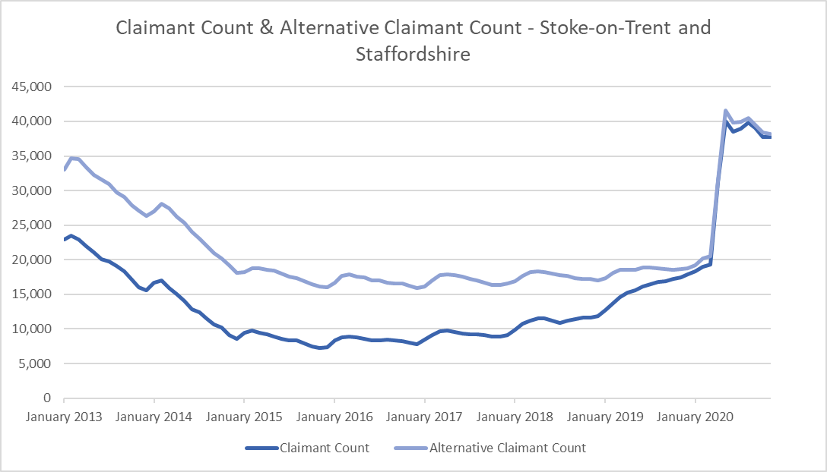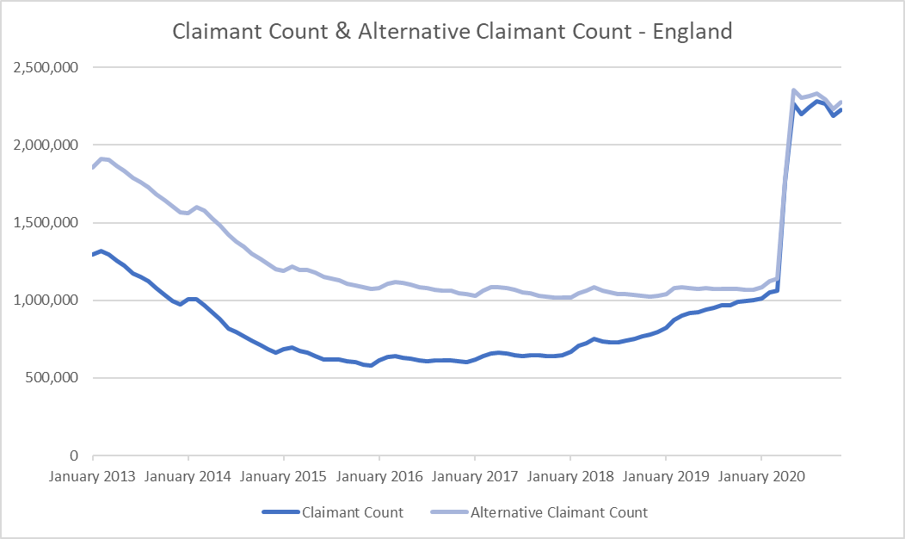

***Source:*** [*ONS claimant count*](https://www.nomisweb.co.uk/datasets/ucjsa) *&* [*DWP Stat Xplore*](https://stat-xplore.dwp.gov.uk/webapi/jsf/login.xhtml)*, January 2013 – November 2020, 2020 SAP boundaries*

Following the financial crisis and resulting economic downturn Stoke-on-Trent and Staffordshire saw the claimant count decline to record low levels. The introduction of Universal Credit in 2018 meant that a broader span of claimants are required to look for work compared to Jobseeker’s Allowance which was reflected in an increase in overall claimants. Throughout this period the claimant count rate in Stoke-on-Trent and Staffordshire has been consistently below the national average.

COVID-19 has had a significant impact on the claimant count both locally and nationally. In December 2020 the claimant count in Stoke-on-Trent and Staffordshire stood at just under 37,600 and had almost doubled (94% increase) when compared to the pre-COVID level in March 2020. However, this was a lower proportional increase than seen nationally (110% increase). Stoke-on-Trent and Staffordshire’s claimant count rate stood at 5.4% in December 2020 which is below the national rate of 6.4%.

These increases need to be viewed in the context of the Government’s change to the criteria for Universal Credit in response to COVID-19, where more people on low incomes have been allowed to claim whilst in work. Although it is clear that the impact of COVID-19 has caused many to find themselves out of work and it is widely recognised that unemployment is likely to increase further during the crisis.

Clearly it will be vitally important that those residents that have been unfortunate to find themselves out of work due to COVID-19 have access to the support and services to reskill and upskill and find new employment such as through the Countywide Redundancy Task Group and Redundancy and Recruitment Triage Service.

A particular concern is the disproportionate impact that has been felt by our young people with a far higher proportion being made unemployed compared to the working age population. To help address this the Government’s Kickstart Scheme will be vital in creating high-quality, six-month work placements for young people to give them a stepping-stone to future work and build the confidence they need for the future.

**Income, Employment and Education deprivation:**

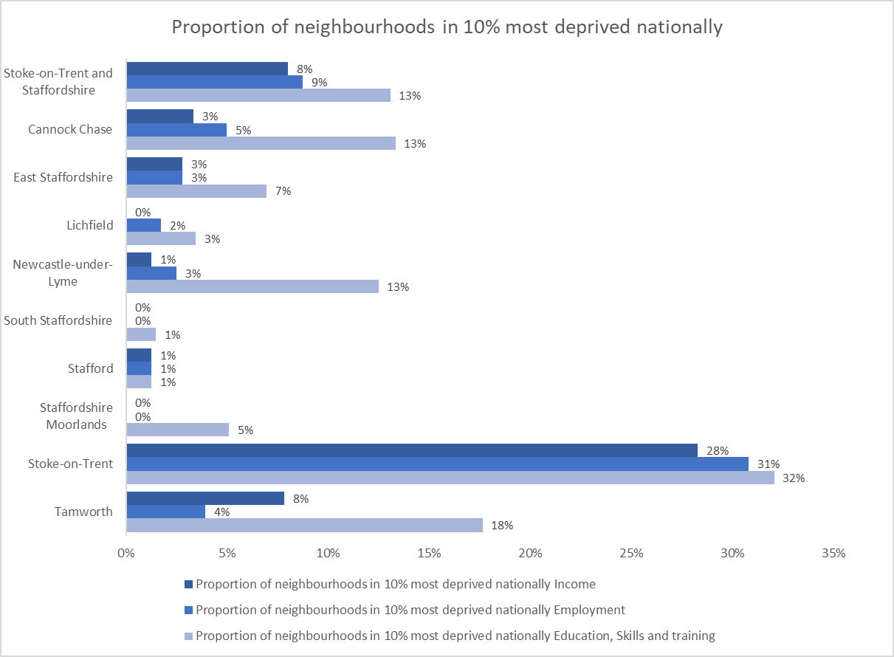

***Source:*** [*Index of Multiple Deprivation, MHCLG, 2019, 2017 LEP boundaries*](https://www.gov.uk/government/statistics/english-indices-of-deprivation-2019)

Generally, income, employment and education deprivation across Staffordshire is comparatively low, however there are clear pockets of deprivation particularly in Tamworth, Cannock Chase and Newcastle-under-Lyme. However, Stoke-on-Trent has around a third of neighbourhoods in the 10% most deprived nationally.

Clearly neighbourhoods which are deprived of income, employment and education are the areas that generally suffer from wider deprivation issues such as poor living standard and health issues. There are a wide range of Government support programmes in place to support these areas and the SAP recognises that it has a key role in improving skill levels in these areas to help level up opportunities across Stoke-on-Trent and Staffordshire. This also forms part of the LIS and SAP inclusive growth agenda.

**Skills Supply**

**Skills Supply – Summary**

* Skills levels in Stoke-on-Trent and Staffordshire have increased rapidly over recent years, this has helped attract higher value roles to the local area and seen wage levels improve. However, there still remains a gap to the national average for higher level skills at level 4+. The reasons for this underperformance are complex and relate to issues such intergenerational low educational achievement within ex-mining and deprived areas alongside issues with school performance. In some areas this has created a low skills equilibrium where the economy is dominated by low value added, low skills and low wages.
* The recently developed LIS has a clear ambition to drive economic growth and improve productivity to help close the gap to the national average, it is recognised that continuing to raise local skill levels is a fundamental element of achieving this ambition. This in turn can help raise wage levels and ambition leading to greater prosperity and a high quality of life for our local residents.
* Effective collaboration and partnership working between providers and businesses is key to ensuring that supply meets the changing demand from industry. Although the local FE system is effective at addressing school-underperformance issues by helping students achieve higher skill levels whilst in FE, the recent decline in participation and achievements due to demographic change means that it is even more vital that those in FE do achieve higher skill levels in the right sector subject areas to support growth in priority sectors.
* While we have also seen a higher proportional decline in apprenticeship achievements than seen nationally over the last year, which may reflect the continuing issues faced by businesses with utilising the apprenticeship levy and investing in apprentices to develop their businesses. To help increase the uptake of apprenticeships there is also evidence that some businesses require more information on apprenticeships and guidance with incorporating them into a business model.
* Our two universities and other HE providers provide the higher skills required to drive economic growth and increase productivity, with clear specialisms in key sector subject area including health and social care, digital and engineering to support growth in key priority sectors such as advanced manufacturing, construction and advanced logistics.
* The SAP is working closely with businesses, universities, colleges, independent training providers and schools to develop a shared understanding of the rapidly changing economy and how supply of skills can meet current and future labour market demand. The SAP is also engaging with key skills stakeholders to ensure that there is clear understanding of the local opportunities presented by national policies including the Apprenticeship Levy, T-Levels, Advanced Learner Loans, Kickstart etc. alongside effective targeting of capital investment and funding e.g. AME Hub. Ensuring our residents have access to high quality careers education, information and guidance and upskilling and retraining pathway opportunities is a core strategic priority of the SAP to enable all to play an active part in the local economy and wider community.
* The importance of partnership working through the SAP has been heightened by the impact of COVID-19 on the economy and the accelerated changes that have been witnessed in the demand for skills including new ways of working leading to the need for more advanced digital skills across all sectors. Clearly COVID-19 has also impacted the delivery of skills with the requirement for many qualifications to quickly be moved to online learning, although for some courses this is not possible and is likely to impact some areas of supply. The pandemic has also seen student confidence in achieving a positive employment outcome following their learning, SAP partners have a key role to play in ensuring that those leaving education have the right skills to widen their career prospects and obtain sustained employment e.g. further developing the local offer for the achievement of advanced digital skills relevant to large parts of the economy.

**Qualification levels:**

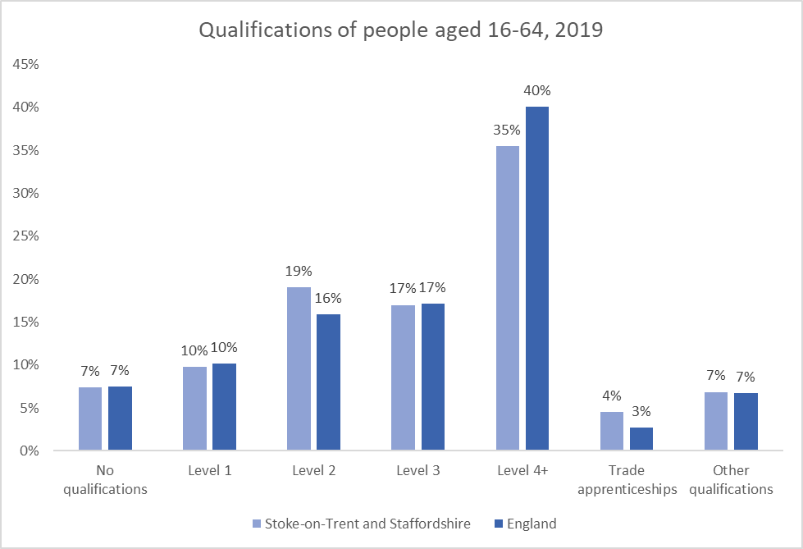

***Source:*** [*Annual Population Survey, January 2019 – December 2020, 2020 SAP boundaries*](https://www.nomisweb.co.uk/datasets/apsnew)

Adult qualification levels in Stoke-on-Trent and Staffordshire have been improving for a number of years, with faster improvement than seen nationally since 2011. The local area has seen those qualified to level 4+ increase from 25% in 2011 to 35% in 2019 and has closed the gap to the national average of 40%. This is similar to what has been seen at level 3+ and clearly shows that the skills of the local workforce have improved considerably over recent years providing a far more skilled labour market to help drive economic growth and improve productivity. There are further opportunities for improvement in higher adult skills if school performance can be improved leading to higher progression pathways into FE and then HE.

Stoke-on-Trent and Staffordshire has also seen working age residents with no qualifications improve at a faster rate than nationally, declining from 12% in 2011 to 7% in 2019 and is now below the national average. This is important given the drive for more inclusive growth with the LIS and reflects well on the local skills system which is addressing a legacy of low adult skill levels within deprived, ex-mining and traditional manufacturing areas.

Considering different groups of residents in Stoke-on-Trent and Staffordshire, it is apparent that females are more likely to hold higher qualifications than males with 41% of females having a level 4+ qualification compared to only 30% of male. This gender gap is far wider than seen nationally where 42% of females and 38% of males hold level 4+ qualifications. It is also seen that males are more likely to have no formal qualifications with 9% compared to 6% of females. Males are also far more likely to have a trade apprenticeship with 7% compared to 2% of females. Also, those in employment are far more likely to have a higher qualification than those thar are not in employment and much less likely to have no formal qualifications. This indicates the importance of a good education and progress to higher skill levels in order to access employment.

At the local authority level there are wide variations in skills attainment with Stafford having the highest proportion of residents qualified to level 4 + at 53% compared to Tamworth which has the lowest proportion of 25%. While Stoke-on-Trent has the highest proportion of residents with no formal qualifications at 13% compared to Stafford which has the lowest proportion of 3%.

**FE Education and Training Achievements**:

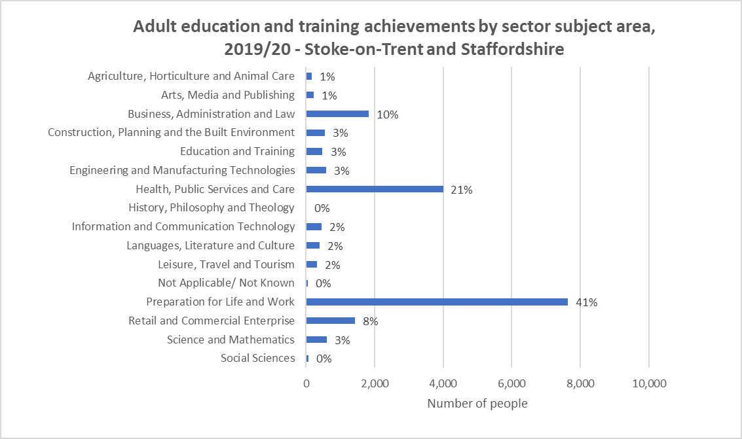

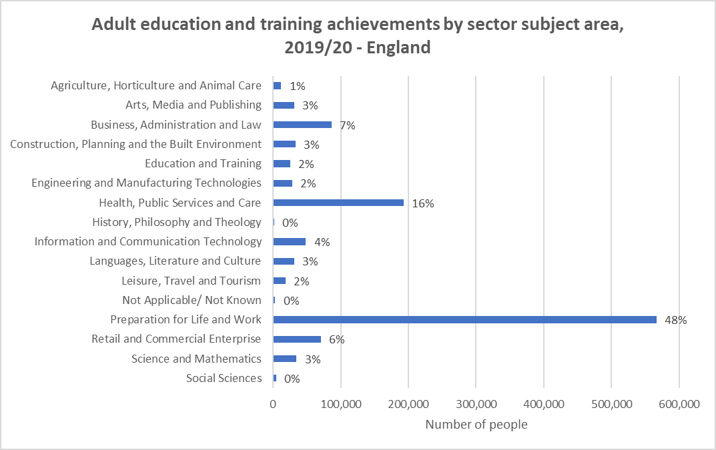

***Source:*** [*Further Education & Skills data, DfE, (published 2020), 2020 SAP boundaries*](https://content.explore-education-statistics.service.gov.uk/mwg-internal/de5fs23hu73ds/progress?id=OSMOa91TO3ceGfaccz26ZmbqVh0nyycv3QdPWK8xiZs,)

FE education and training participation has seen a 22% decline over the last year from 19,390 in 2018/19 to 15,020 in 2019/20, which is larger than the 19% decline seen nationally. The main declines have been seen in level 2 or below. These declines are related to recent demographic changes where Stoke-on-Trent and Staffordshire saw a larger decline in the 16-19 population compared to nationally, with a 17% decline between 2010-2020 compared to a 9% decline nationally.

Overall, there were 18,768 FE education and training achievements in Stoke-on-Trent and Staffordshire in 2019/20. Achievements are concentrated in the sector subject areas of ‘Health, Public Services and Care’, ‘Business, Administration and Law’, and ‘Retail and Commercial Enterprise’. This is similar to the picture seen nationally and relate closely to changing demand within the economy.

‘Health, Public Services and Care’ achievements are vital to address the increasing demand for health and social care services due to the ageing population and more recently the fight against COVID, while there has also been increased demand for wider public services to address the impacts caused by COVID.

The cross-cutting nature of ‘Business, Administration and Law’ achievements are important in supporting existing and new businesses to grow and drive the local economy. Providing young people with the necessary business knowledge and skills to start-up a business and be viable is crucial to the economic recovery from COVID.

‘Retail and Commercial Enterprise’ achievements are important to any local economy due to the presence and size of these sectors in all areas. It is clear that hospitality and non-food retail on the high street has been hit hard by COVID and there has been a significant consumer channel shift to online shopping. Moving forward there may be a requirement to ensure that such achievements are future proof and provide learners with the necessary skills to support the dynamic change we are seeing with retail.

It is also important to recognise the importance of ‘Information and Communication Technology’, ‘Engineering and Manufacturing Technologies’ and ‘Construction, Planning and the Built Environment’ achievements in supporting several of our priority sectors including advanced manufacturing, construction including modern methods of construction, and advanced logistics.

**Apprenticeship Achievements:**

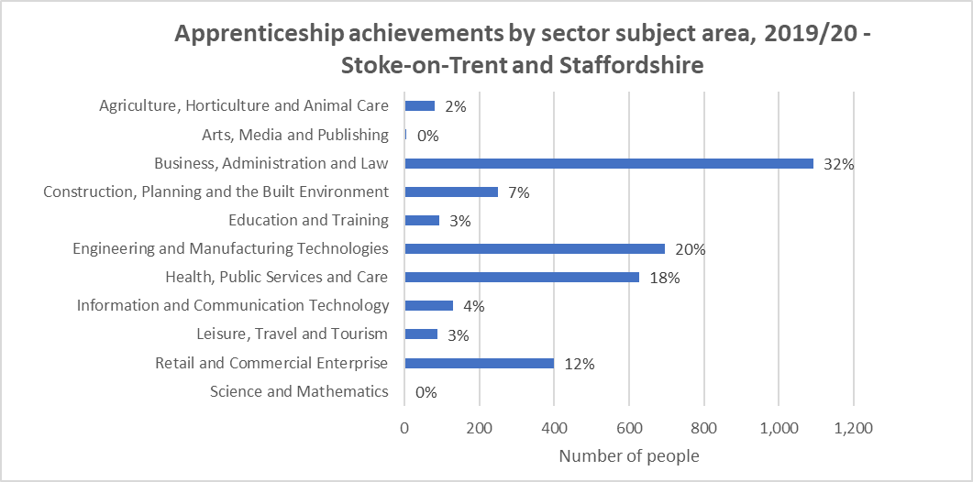

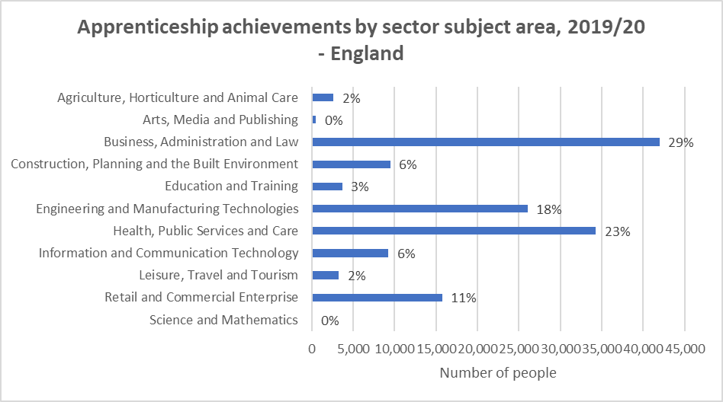

***Source:*** [*Apprenticeships data, DfE, (published 2020), 2020 SAP boundaries*](https://content.explore-education-statistics.service.gov.uk/mwg-internal/de5fs23hu73ds/progress?id=plRcC6oJ_FvfLSWwFxSK8z0GBIR7h86rUIjJ2N_YRwA,)

Apprenticeships starts have seen a 17% decline over the last year which is lower than the 18% decline seen nationally, dropping from 9,320 in 2018/19 to 7,720 in 2019/20, while participation has only seen a slight decline of 560 during the same period to a total of 17,220 in 2019/20.

Overall, apprenticeship achievements have declined by 25% over the last year from 4,620 in 2018/19 to 3,460 in 2019/20, which is higher than the 21% decline seen nationally. Achievements are concentrated in the sector subject areas of ‘Business, Administration and Law’, ‘Engineering and Manufacturing Technologies’, and ‘Health, Public Services and Care’. This is similar to the picture seen nationally and as with FE achievements relate closely to changing demand within the economy and the vocational nature of apprenticeships.

Clearly the apprenticeship levy is not functioning to encourage employers to invest in apprentices in their respective businesses. It is also being widely perceived as a further tax on business who complain the funds raised do not cover the training costs they incur. A recent SAP Business survey also shows that almost 1 in 10 businesses (8%) in the SSLEP area pay the Apprenticeship Levy, however, less than half of them currently have levy apprentices. Many businesses have suggested that the apprenticeship levy is difficult to navigate and require support and guidance.

There may be opportunities to increase take up of apprenticeships among employers in the SSLEP area. More than 8 in 10 businesses do not have apprentices currently and this includes some paying the apprenticeship levy. In most cases, those without apprentices attribute this to a lack of opportunities in the company, which may in some cases be overcome through greater communication of information on how apprenticeships work and where they can be relevant. Other issues that intervention could help to address include lack of knowledge about apprenticeships and a belief that this takes too much management time as well as difficulties finding funding, apprentices and relevant frameworks.

**HE Qualifiers:**

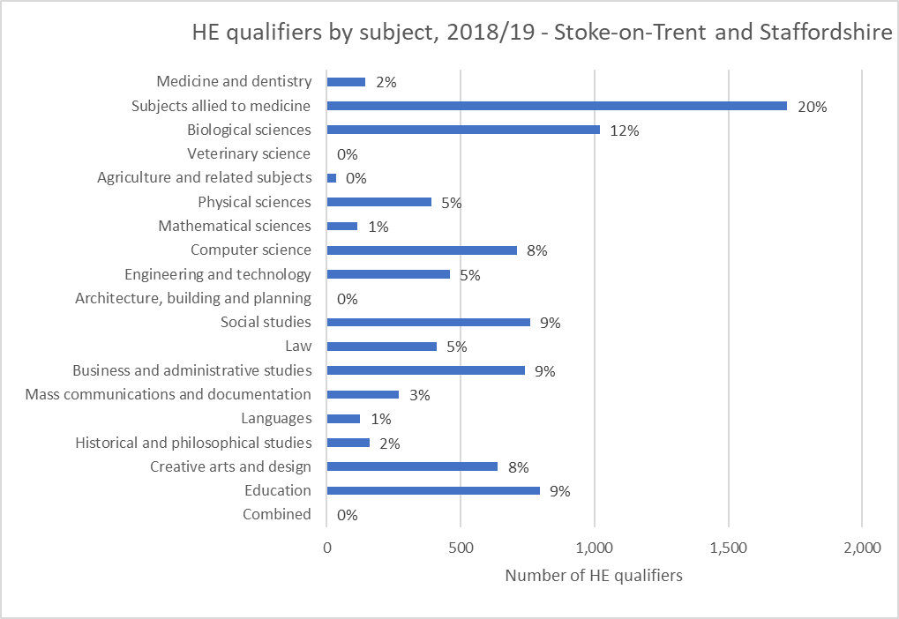

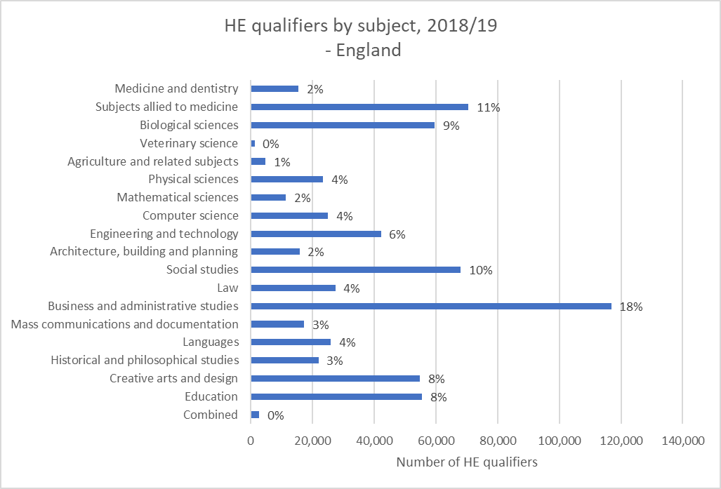

***Source:*** [*HESA, 2018/2019 qualifiers (published 2020), 2020 SAP boundaries*](https://www.hesa.ac.uk/data-and-analysis/students/table-17)*)*

HE qualifiers in Stoke-on-Trent and Staffordshire from Keele and Staffordshire Universities are concentrated in subjects allied to medicine and biological sciences, accounting for 2,740 qualifiers which was nearly a third (32%) of all qualifiers in 2018/19 far higher than the 20% seen nationally. It is also notable that Stoke-on-Trent and Staffordshire has double the proportion of qualifiers in computer science, with 710 qualifiers in 2018/19 which was 8% of all qualifiers compared to 4% nationally. The local area also has half the proportion of qualifiers in business and administrative studies, with 9% compared to 18% nationally.

Clearly, as previously discussed health and social care is a large and growing sector in Stoke-on-Trent and Staffordshire with increasing demand from the ageing population and further demand generated from the impact of COVID. It is therefore encouraging that both of our universities have significant strengths in medicine and biological sciences, helping to supply the much needed skills in health and social care.

It is also encouraging that with Staffordshire University we have a significant asset in the delivery of advanced digital skills through computer science courses alongside engineering and technology. These will be vital to support the delivery of growth within our key priority sectors including advanced manufacturing, construction and advanced logistics.

**KS4 destinations:**

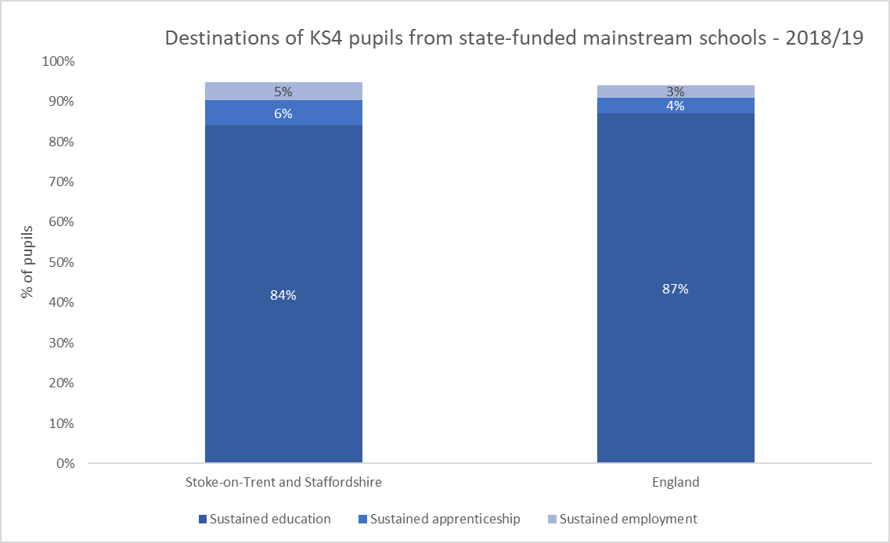

***Source:*** [*KS4 destination measures, DfE, 2018/19 (published 2020), 2020 SAP boundaries*](https://explore-education-statistics.service.gov.uk/find-statistics/key-stage-4-destination-measures#releaseHeadlines-charts)

The vast majority of Stoke-on-Trent and Staffordshire KS4 pupils from state-funded mainstream schools go into sustained education, with 84% choosing this pathway which is lower than the 87% seen nationally. It is notable that the proportion of KS4 pupils in Stoke-on-Trent and Staffordshire progressing into a sustained apprenticeship is above the national average at 6% compared to 4% nationally. The latter will be at least in part related to the industrial heritage of the local area with previous generations taking a vocational rather than academic route and the continuing strong manufacturing base in the area.

Clearly it is encouraging that Stoke-on-Trent and Staffordshire has 95% of KS4 pupils progressing into a sustained positive destination compared to 94% nationally. The fact that more of our school leavers are choosing a vocational pathway is also of benefit to our local economy and reflects well on careers education, information, advice and guidance in Stoke-on-Trent and Staffordshire.

**16-18 destinations:**

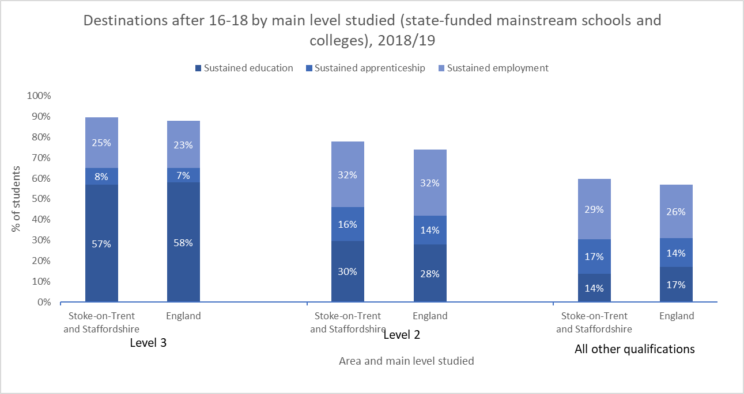

***Source:*** [*16-18 Destination Measures, DfE, 2018/19 (published 2020), 2020 SAP boundaries*](https://explore-education-statistics.service.gov.uk/find-statistics/16-18-destination-measures)

The main destination for 16-18 students in Stoke-on-Trent and Staffordshire is further sustained education at just under half (45%) of leavers which is slightly lower than the national average of 47%. Stoke-on-Trent and Staffordshire has a slightly lower proportion progressing into level 3 qualifications than nationally with more moving into level 2.

Although this gap is addressed through those choosing to progress into a sustained apprenticeship, with 11% in Stoke-on-Trent and Staffordshire choosing this option compared to only 9% nationally. Stoke-on-Trent and Staffordshire has a higher proportion of KS5 leavers progressing into a level 3 apprenticeship than nationally and the same is true for level 2 apprenticeships.

Stoke-on-Trent and Staffordshire has a slightly higher proportion of KS5 students moving into sustained employment with 27% compared to 25% nationally. Stoke-on-Trent and Staffordshire has a higher proportion that progress into sustained employment at level 3 and the same at level 2.

As with KS4 destinations, it is clear that Stoke-on-Trent and Staffordshire has more young people leaving KS5 that choose to take a vocational training pathway such as an apprenticeship than the national average. Again, this will at least in part be due to the industrial heritage of the local area and the economic structure of the local economy. It is welcomed that CEIAG is helping to guide young people leaving KS5 to choose a mix of both academic and vocational pathways to support future economic growth in our priority sectors.

**Adult FE and skills destinations:**

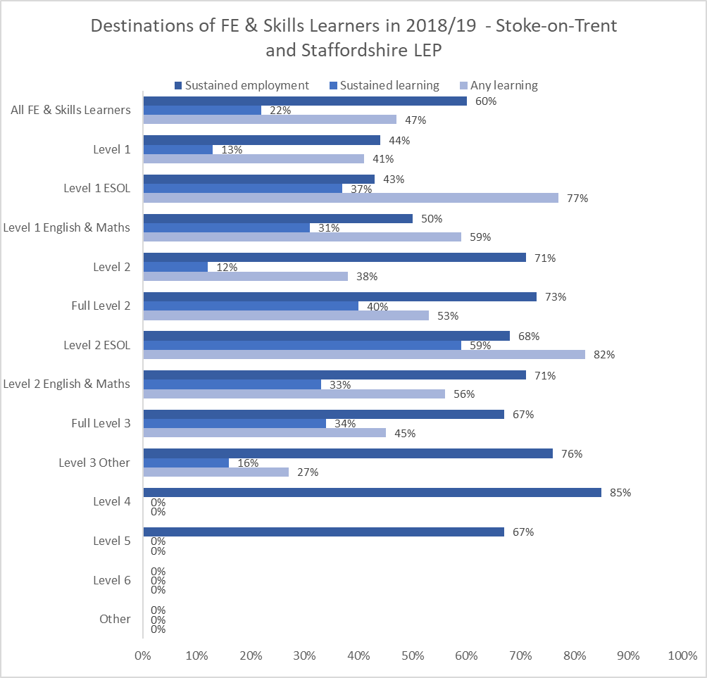

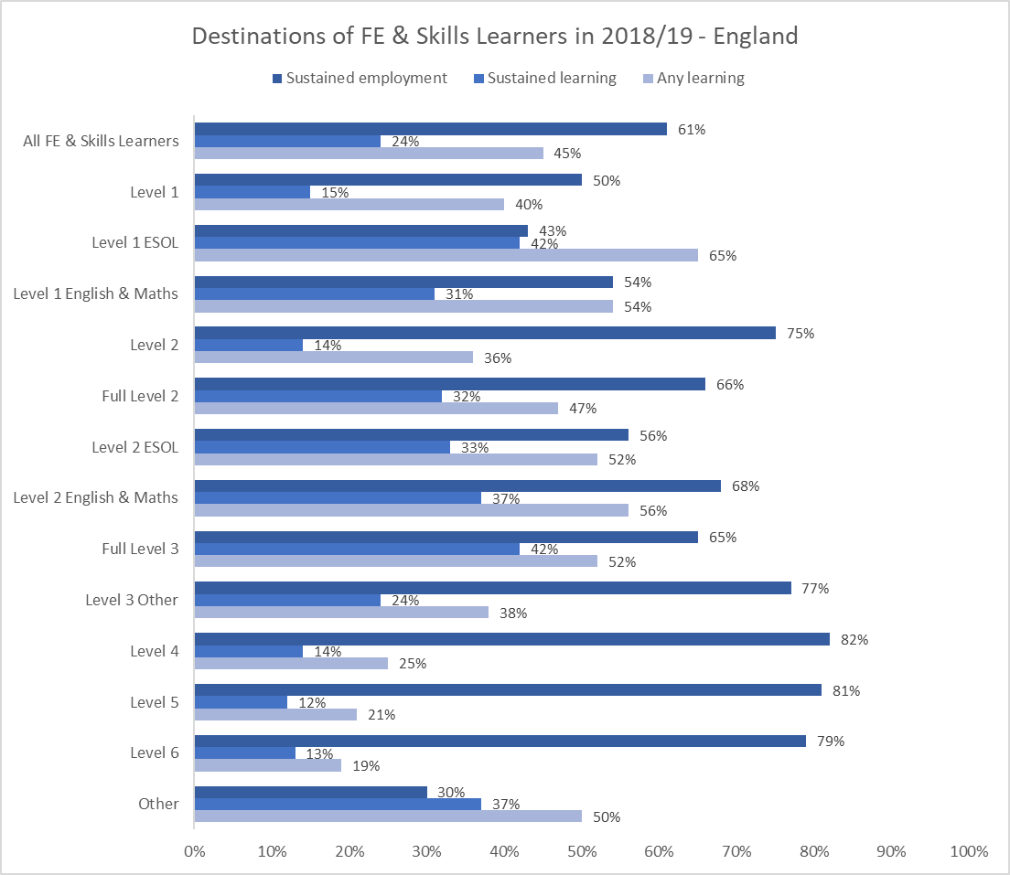

***Source:*** [*FE outcome based success measures, 2018/19 destinations, DfE, (published 2020), 2018 LEP boundaries*](https://explore-education-statistics.service.gov.uk/find-statistics/further-education-outcome-based-success-measures)

The overall destination profile of adult FE & skills learners for Stoke-on-Trent and Staffordshire varies from the national picture, with 60% moving into sustained employment slightly lower than the 61% seen nationally, while only 22% move into sustained learning compared to 24% nationally. Nearly half (47%) progress into any learning compared to 45% nationally.

As expected of those studying lower level qualifications at level 1 there is generally a higher propensity for such learners to progress into some form of further learning than compared to those studying higher qualifications which are more likely to find sustained employment.

**Apprenticeship destinations:**

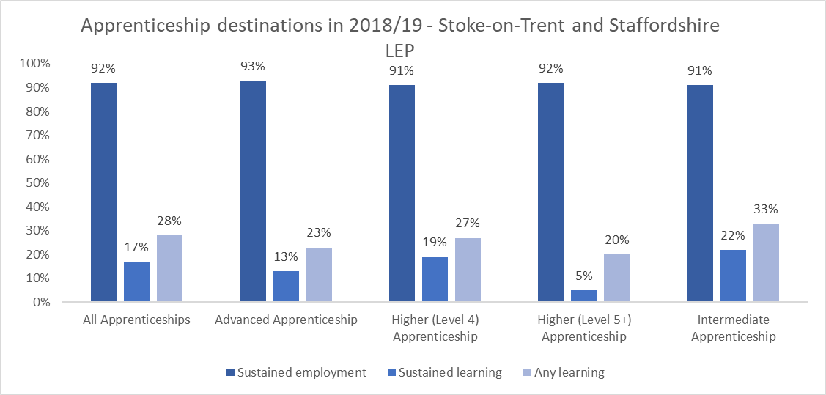

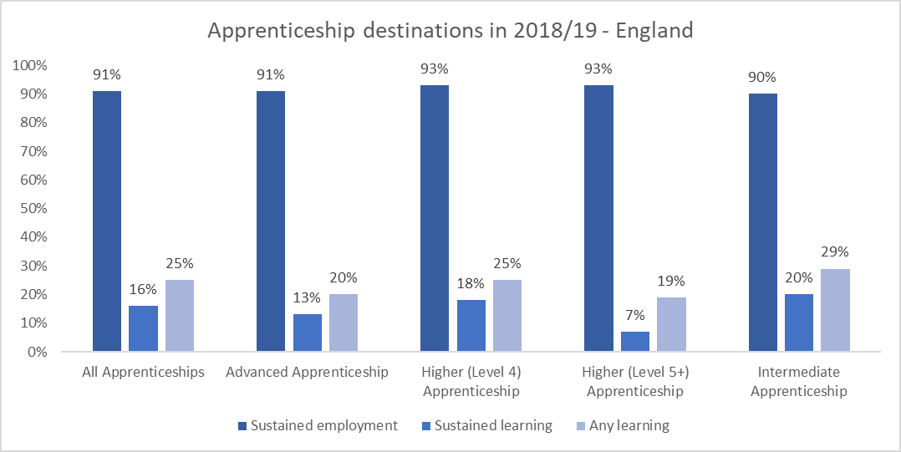

***Source:*** [*FE outcome based success measures, 2018/19 destinations, DfE, (published 2020), 2018 LEP boundaries*](https://explore-education-statistics.service.gov.uk/find-statistics/further-education-outcome-based-success-measures)

Overall, the majority of apprenticeships lead to sustained employment with this being the case for 92% in Stoke-on-Trent and Staffordshire slightly higher than the 91% seen nationally. Nearly a fifth (17%) of apprentices continue on into sustained learning and over a quarter (28%) continue in any learning, which are slightly higher proportions to nationally. Generally, the higher the apprenticeship the greater propensity to continue into sustained employment rather than further learning.

The sector subject areas in Stoke-on-Trent and Staffordshire with the highest likelihood that an apprenticeship will lead to a sustained positive destination are ‘education & training’ with 98% and both ‘engineering & manufacturing’ and ‘business, admin & law’ with 94% compared to the average of 92%. The sector subject areas with the lowest sustained positive destination are ‘leisure, travel & tourism’ with 77% and ‘agriculture, horticulture & animal care’ with 85%.

**HE graduate destinations:**

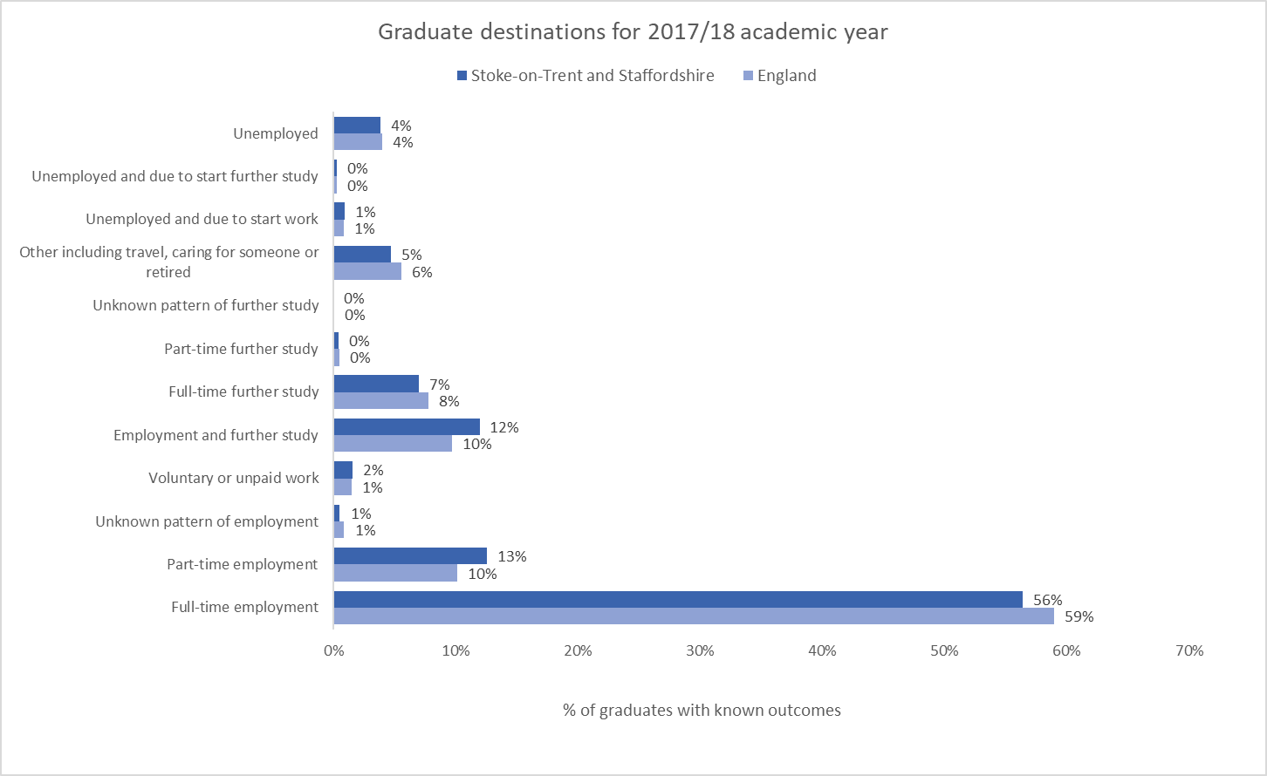

***Source:*** [*HESA, 2017/18 graduates (published 2020), 2020 SAP boundaries*](https://www.hesa.ac.uk/data-and-analysis/graduates/table-6)

The destination profile of HE graduates from local institutions in Stoke-on-Trent and Staffordshire is similar to the profile seen nationally, with by far the highest destination being full-time employment at 56% slightly lower than the 59% seen nationally. Although the gap in full-time employment is closed by those that move into part-time employment with 13% in Stoke-on-Trent compared to 10% nationally. Stoke-on-Trent and Staffordshire also has slightly higher progression into employment and further study at 12% compared to 10% nationally.

Around 7% of HE graduates in Stoke-on-Trent and Staffordshire progress into full-time further study similar to the 8% seen nationally, while both locally and nationally 4% find themselves unemployed.

**Graduate retention:**

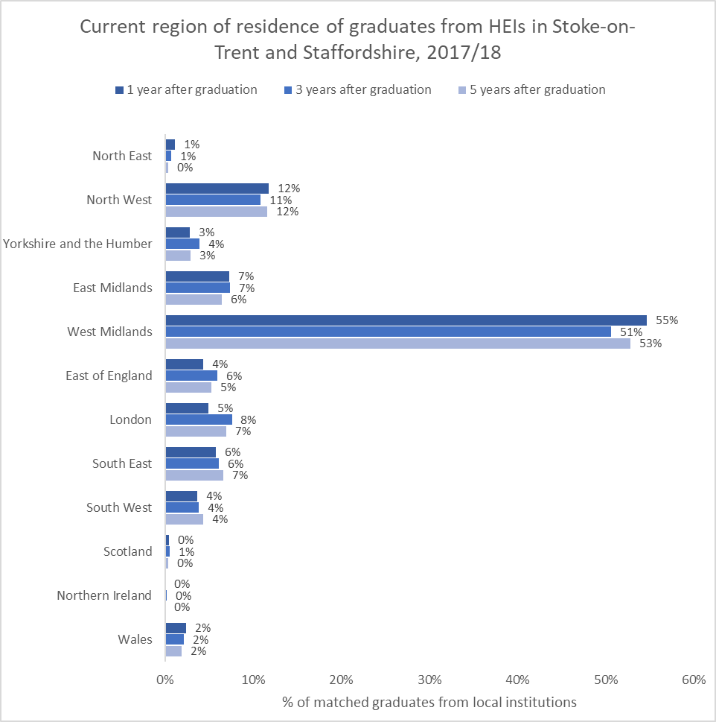

***Source:*** [*Graduate Outcomes in 2017/18, DfE, (published 2020), 2020 SAP boundaries*](https://data.explore-education-statistics.service.gov.uk/api/download/graduate-outcomes-leo-provider-level-data/2017-18/ancillary/Provider_Table_GB.xlsx)

Over half of HE graduates in Stoke-on-Trent and Staffordshire remain in the West Midlands up to 5 years after graduation, the most likely destination for graduates to move to beyond the West Midlands is the North West.

It is found that graduates from Staffordshire University are more likely to remain in the West Midlands when compared to those from Keele University, with 59% from Staffordshire University remaining in the region 5 years after graduation compared to 42% from Keele.

Generally, the cost of living in Stoke-on-Trent and Staffordshire is comparatively good, although recently there have been some areas where housing affordability has become more of an issue including Lichfield and Stafford. The local area has also seen increasing jobs in higher occupations with better salary levels which are likely to be more attractive to graduates. However, the area suffers in terms of its lifestyle offer to graduates when compared to other areas close by such as the larger cities of Birmingham and Manchester which have more extensive assets attractive to graduates lifestyle choices.

**Employer provided training:**

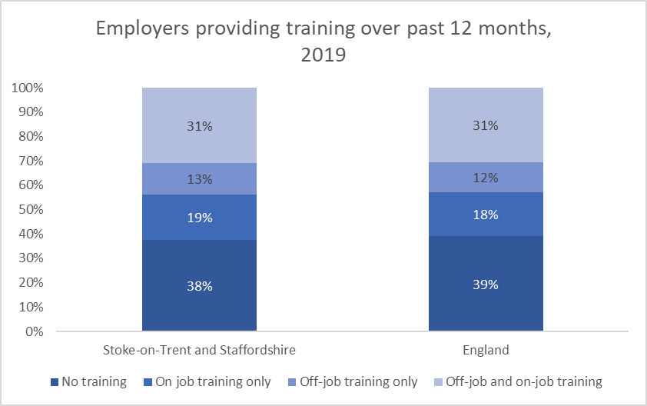

***Source:*** [*Employer Skills Survey, 2019 (published 2020), 2019 LEP boundaries*](https://www.gov.uk/government/publications/employer-skills-survey-2019-england-results)

In Stoke-on-Trent and Staffordshire nearly two thirds (62%) of employers provided training over the past 12 months, with the main form of training being a mix of off-job and on-job training. This is a similar picture to that seen nationally (61%).

The main type of training funded or arranged for employees was ‘job specific training’ with 83% of those providing training stating this compared to 85% nationally, followed by ‘health & safety/first aid training’ (75% compared to 71%), ‘basic induction training’ (55% compared to 61%) and ‘training in new technology’ (47% compared to 48%). There were also 57% of employers training which were using online training or e-learning compared to 56% nationally.

Of those employees receiving training, 24% were in ‘high-skill’ roles such as managers and professionals lower than the 37% nationally, while 37% were in ‘service-intensive’ roles such as ‘sales and customer services staff’ and ‘caring, leisure and other service staff’ above the 23% nationally.

Of those employers that did not provide training over the past 12 months, the main reason was that all staff are fully proficient so there is no need for training with 80% saying this was the case compared to 70% of non-training employers nationally. One in ten non-training employers suggested that there was no training available in relevant subject area above the 6% nationally. While one in 20 non-training employers identified a lack of money for training as a barrier which is in-line with the national picture.

Although non-trainers were taking action to aid the development of employees including ‘supervision to ensure that employees are guided through their job role over time’, ‘provided opportunities for staff to spend time learning through watching others perform their job’ and ‘allowed staff to perform tasks that go beyond their strict job role and providing them with feedback’. However, only 57% of non-trainers were providing any these broader development activities which was below the 63% seen nationally.

**Skills Demand**

**Skills Demand - Summary**

* The COVID-19 pandemic has seen significant impact to the economy with significant increases in unemployment as more and more businesses have had to close due to reduced demand and trade. All sectors have experienced change during the crisis, with those hardest hit in terms of business failure and job losses including ‘Accommodation & food services’, ‘Arts, entertainment, and recreation’, ‘Wholesale & retail’, ‘Manufacturing’ and ‘Construction’. Large parts of the national and local policy response to COVID-19 has centred on supporting viable businesses to survive and saving jobs.
* However, there have been some current sector growth opportunities where there has been increasing employment demand. Firstly, the demand for digital skills across all sectors and at all levels has been accelerated by the crisis both to support the adoption of new technologies including automation and AI and to enable new ways of working such as home working. This has highlighted skills supply issues, particularly for higher level advanced digital skills e.g. coding, computer programming, machine learning, data science etc. To address this SAP partners have put in place a wide range of initiatives to improve digital skills in the local area with new curriculum offer and capital investment in digital skills provision e.g. DfE Digital Skills Bootcamps.
* There has also been notable demand from a number of existing large sectors, with health and social care seeing high demand for labour and skills prior to the pandemic to support the ageing population but that demand has been heightened due to COVID-19. There is also concerns within the sector of the potential impact on labour and skills supply caused by Brexit, where it may become more difficult to source workers from the EU. Domestically health and social care workers have been on the frontline ion the fight against COVID-19 and have been recognised as ‘key workers’ but this has further highlighted issues regarding pay levels within certain occupations and the difficulty this causes with domestic recruitment to such roles.
* We have also seen increased demand within the logistics sector, with transport and storage roles needed to support the accelerated growth in online retail caused by the crisis and resultant lockdown restrictions. Although construction was initially impacted with a number of SMEs either having to temporarily or permanently close during the initial lockdown, there are a number of growth opportunities within the sector. Demand for construction roles is being generated by infrastructure projects such as HS2, Get Building Fund Projects, West Midlands Freight Interchange, alongside housing to meet Government targets and retrofitting as part of the building back greener agenda. The SAP is supporting residents that may have found themselves out of work due to COVID to reskill and upskill in these areas such as through the national retraining and kickstart schemes.
* In terms of future growth opportunities to recover the losses from COVID-19 in the long-term we recognise the potential for growth in high-skilled high-value jobs in sectors including:
  + Digital (cross-cutting - new technologies and ways of working)
  + The Green Economy/Climate Change/Clean Energy
  + Engineering & Advanced Manufacturing (Automation/AI)
  + Modern Methods of Construction (Automation/AI/Retrofitting)
  + Advanced Logistics (Automation/AI)
  + Health and Social Care (Digitisation of Services/New Technologies)
* The SAP is actively supporting local businesses to make use of new technologies such as AI and automation, alongside ensuring that there is the availability of skills in the local workforce to support this type of high value growth. A key aspect of this is developing high quality CEIAG working the likes of the Careers and Enterprise Company to ensure that local residents have the knowledge and understanding of the demands for skills within the local economy now and in the future.

**Online vacancies:**

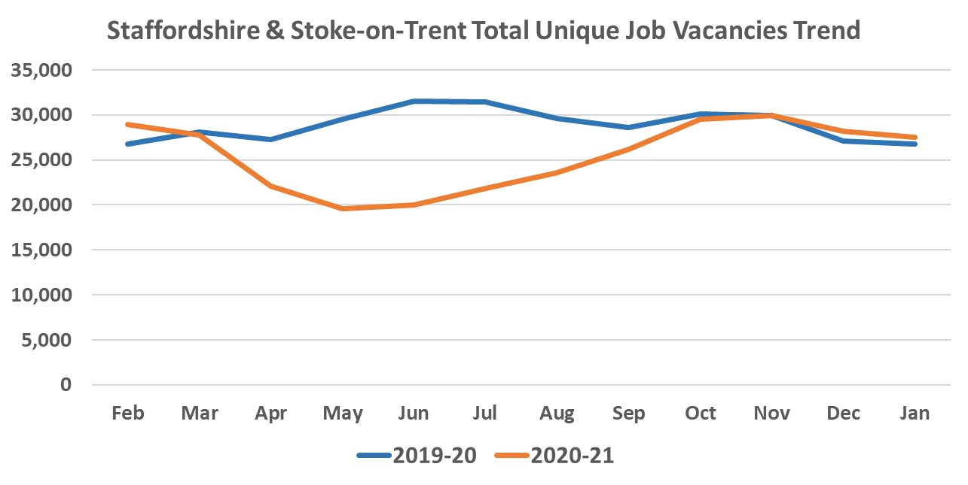

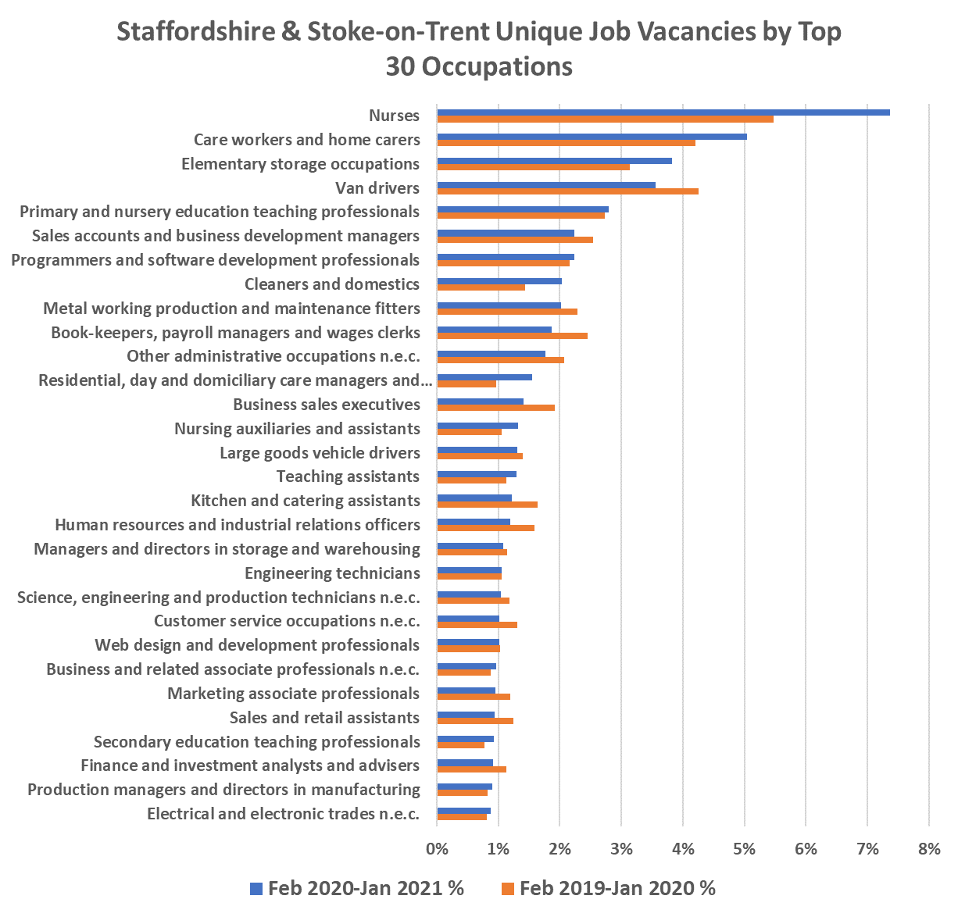

***Source:*** [*EMSI Online Job Vacancies, Jan 2021 (published 2021), 2019 LEP boundaries*](https://www.gov.uk/government/publications/employer-skills-survey-2019-england-results)

As has been the case nationally, Stoke-on-Trent and Staffordshire saw total online job vacancies impacted significantly by the pandemic with monthly totals dropping to below 20,000 a month early in the crisis during May and June 2020 more than a third lower than levels seen during 2019. However, overall job vacancies have since recovered to similar levels seen a year earlier.

As expected, occupations in the health and social care sector have seen the highest demand during the pandemic with nurses having by far the highest levels of job vacancies, while care workers and managers have also seen high and increasing demand during the crisis.

Alongside health and social care, the logistics sector has also seen increased demand for roles such as elementary storage occupations, van drivers and LGV drivers to support the growth in online shopping caused by changing consumer behaviour during lockdowns and restrictions.

There is also high demand for primary and nursery education teaching professionals, which is an area which was badly impacted during lockdown. While in manufacturing metal working production and maintenance fitters remain the occupation in most demand.

As well as these more sector specific roles, there is continuing and growing demand for workers which support numerous sectors including sales and business development mangers to support with changing business models, digital roles such as programmers and software development professionals, book-keepers and payroll managers, admin roles and cleaners.

**Sector growth forecasts:**

Please note these forecasts were produced prior to COVID-19:



***Source:*** [*Working Futures, 2017-2027 (published 2020), 2017 LEP boundaries*](https://warwick.ac.uk/fac/soc/ier/research/wf/)

The economic structure of Stoke-on-Trent and Staffordshire has seen a shift to more service-based industries over recent years and this is reflected in the growth forecasts with support services expected to see the highest growth between 2017-2027.

Our tourism and leisure offer has continued to strengthen and this is reflected by ‘arts and entertainment’ forecast to be the second highest sector for growth up to 2027. Although it is important to consider the impact of COVID-19 on this sector given that it is one of the sectors which has been hardest hit by the pandemic and therefore growth is likely to be downgraded for the foreseeable future.

Health and social care is likely to see significant continued growth not least due to the ageing population and impact of COVID but there are emerging opportunities from digital and med-tech, with Keele University being a key asset, which we are looking to grow further.

We have seen strong improvement in adult skill levels and this is starting to be reflected in the occupational structure of our local economy with more jobs in professional services being created leading to improvement in pay levels. We have also had a focus on improving digital skills which support all sectors of the economy and will be vital to future economic growth and raising productivity in the post-COVID economy.

Although we are forecast to see a decline in traditional manufacturing which is likely to be accelerated by COVID-19, we have seen considerable growth in engineering and advanced manufacturing and this remains a key priority sector within our LIS. We have strong STEM provision within our universities and colleges to support this and alongside the internationally renowned companies such as JCB and JLR we have growth opportunities in specialism areas, such as automotive, aerospace, advanced materials, med-tech, agri-tech, energy and other technology-intensive industries.

We also have a strategic focus on two further local strength sectors, namely advanced logistics and construction. Our central location and strong connectivity alongside the availability of land and premises mean that we have clear opportunities for further growth in logistics. These opportunities have been further heightened by COVID-19 accelerating the shift to online retail with increasing demand for warehousing and wider supply chain logistics. We are also keen to take advantage of new digital technologies such as automation and AI are driving growth in highly productive advanced logistics.

Our strong construction base means that we have greater ability to take advantage of opportunities presented by Government house building targets and major infrastructure projects such as HS2 and the West Midlands Freight Interchange. We are also looking to take advantage of opportunities presented by new digital technologies which are driving growth in Modern Methods of Construction including offsite automation & AI. Alongside this it is clear that COVID-19 has raised the need to build back greener and the Green Economy presents further growth opportunities through environmentally sustainable construction and renewable energy.

**Occupation growth forecasts:**

Please note these forecasts were produced prior to COVID-19:



***Source:*** [*Working Futures, 2017-2027 (published 2020), 2017 LEP boundaries*](https://warwick.ac.uk/fac/soc/ier/research/wf/)

Unsurprisingly, occupations in health and social care are forecast to see the highest growth between 2017-2027. Given that health and social care is the second largest sector in Stoke-on-Trent and Staffordshire and has seen increasing demand over recent years due to the ageing population and further demand due to COVID-19 we expect that roles in the sector will continue to grow over coming years.

Given the recent jobs increase in service-based industries we have witnessed it is expected that there will be further growth in customer service occupations, particularly to support online services such as retail. The further development of digital skills will be important to ensure that the local workforce has the skills necessary to make the transition to online e-commerce.

The impact of COVID-19 has been felt by all parts of the economy and it is expected that has we move into the economic recovery and transformation phases there will be a greater need from businesses for managers to manage change and build back stronger.

Clearly occupations which are forecast to see either low growth or decline are those that are being displaced by new technologies such as AI and automations, this is particularly true for lower skilled, manual occupations. It is therefore fundamentally important that residents in such occupations are supported to reskill and upskill enabling them to access new roles within the economy and support further economic growth.

**Skills that need developing:**

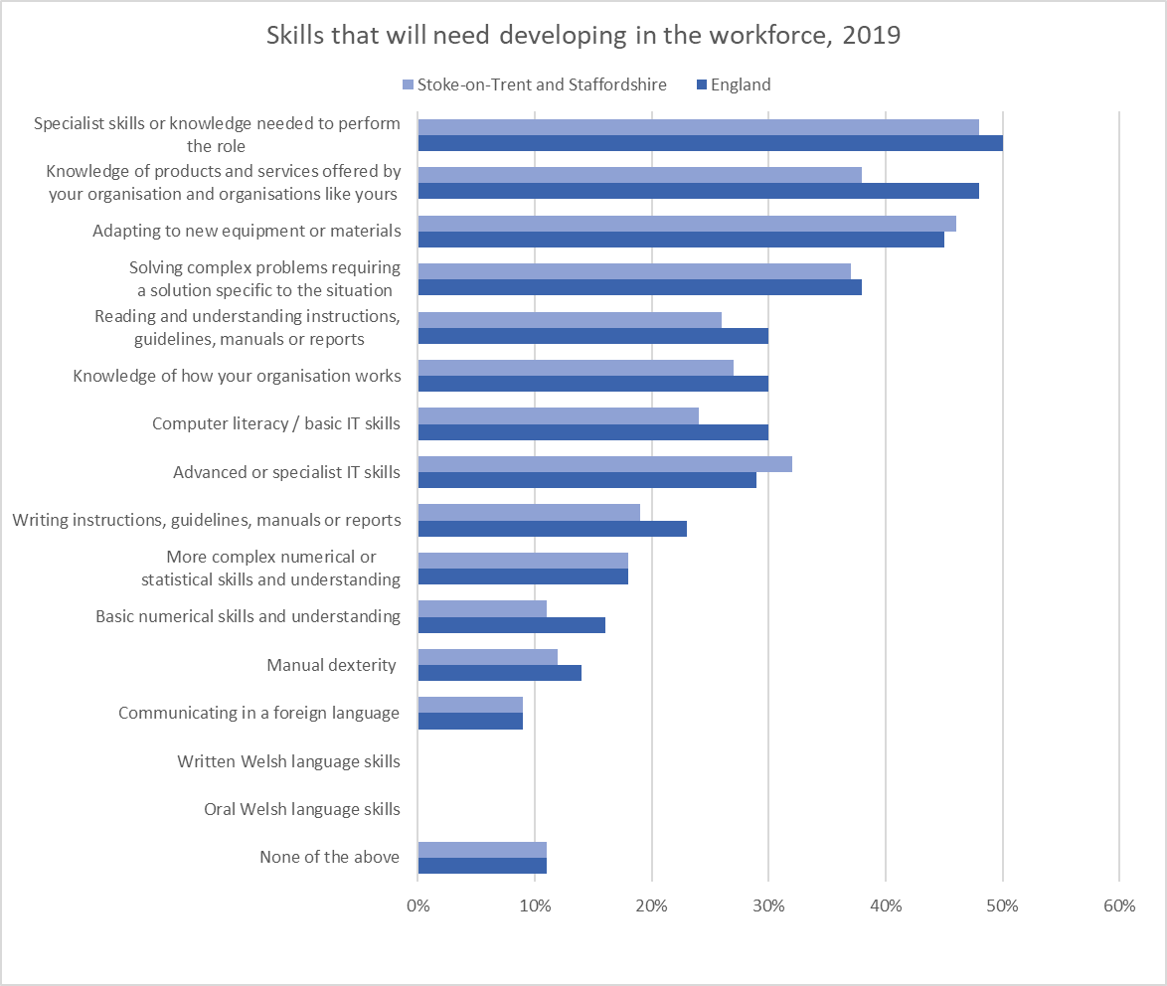

***Source:*** [*Employer Skills Survey, 2019 (published 2020), 2019 LEP boundaries*](https://www.gov.uk/government/publications/employer-skills-survey-2019-england-results)

The world of work is rapidly changing and it is increasingly apparent that those within the workforce will need to change roles and continually develop their skills more so than in the past.

The skills that local and national employers anticipate will need developing the most include ‘specialist skills or knowledge needed to perform the role’, ‘knowledge of products and services’, ‘adapting to new equipment or materials’, and ‘complex problem solving’.

We comparing the skills identified as in need of developing compared to the national picture there are a couple of areas which stand out, firstly businesses in Stoke-on-Trent and Staffordshire were less likely to feel that ‘knowledge of products and services’ needed developing with only 38% of businesses stating that was the case compared to 48% nationally. This may reflect that workers either already have a sound knowledge or that more of the roles found locally do not require such knowledge.

In contrast there is a higher likelihood than nationally that local businesses identified ‘adapting to new equipment or materials’ and ‘advanced or specialist IT skills’ as in need of developing. This likely in part reflects our strong manufacturing base which is going through significant technological change and the wider demand from all sectors for increasingly advanced digital skills to take advantage of new technologies such as AI, automation and machine learning.

**Mapping Skills Supply and Demand**

**Skills Supply and Demand – Summary**

* Currently the alignment between skills supply and demand in Stoke-on-Trent and Staffordshire is comparatively good, with those leaving KS4, KS5, apprenticeships and HE more likely than average to progress to a sustained destination along their learning and career pathways. We also have higher levels of staff proficiency indicating that the skills of the workforce more effectively match the current demand from industry than seen nationally.
* However, when we look at certain parts of the local economy there are some current skills supply issues which need to be addressed, including the ongoing presence of skills shortages, gaps and hard to fill vacancies related to digital (cross-cutting advanced skills), health & social care (nursing and social care workers), advanced manufacturing (declining STEM achievements/apprenticeships), and construction (on-site skills).
* It is apparent that aligning skills supply and demand is becoming more challenging given the increasingly rapid changes within the economy brought about by the fourth industrial revolution.
* There are a number of emerging growth opportunities within sectors such as digital (cross-cutting - new technologies and ways of working), The Green Economy/Climate Change/Clean Energy, Engineering & Advanced Manufacturing (Automation/AI), Modern Methods of Construction (Automation/AI/Retrofitting), Advanced Logistics (Automation/AI), and Health and Social Care (Digitisation of Services/New Technologies).
* These opportunities can only be taken if there are the necessary skills within the local workforce to support business innovation and growth.
* The SAP has a key role in bringing together businesses and providers to ensure supply meets demand now and in the future. SAP partners are working together to put in place new curriculum offers e.g. Staffordshire University Digital innovation Partnerships and Keele University Sustainability Hub, investing in new equipment and facilities for training and skills development e.g. AME Hub, and ensuring that our residents have access to timely high quality careers education, information and guidance.
* Beyond addressing supply issues, there is also a potential opportunity for the SAP to work with local businesses to better understand where workforce skills are currently being underutilised and how skills currently not used may be exploited to support future business growth.
* It is hoped that through this stronger partnership working the SAP can raise skill levels so that there is a more highly skilled local workforce e.g. improving school performance and graduate retention. While also helping to address skills supply and demand mismatch to enable stronger economic growth and raise productivity by ensuring that the local workforce has the skills required by industry now and in the future.
* Ultimately the ambition is for more inclusive higher value growth where everyone can benefit from big gains in productivity through increased prosperity, improved wellbeing and a better quality of life in Stoke-on-Trent and Staffordshire.

**Proficiency of workforce:**

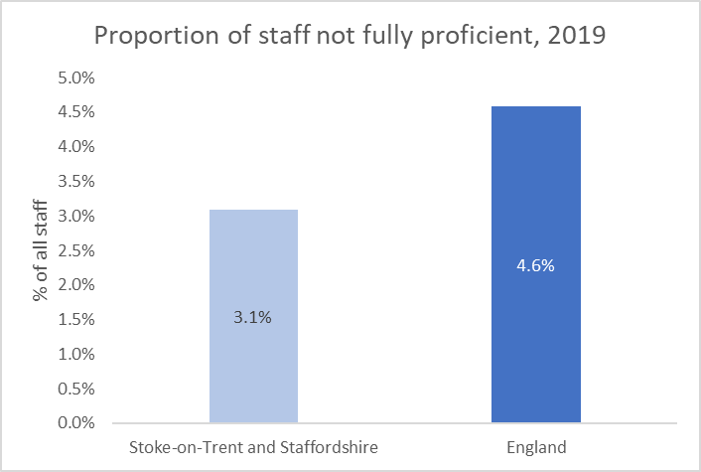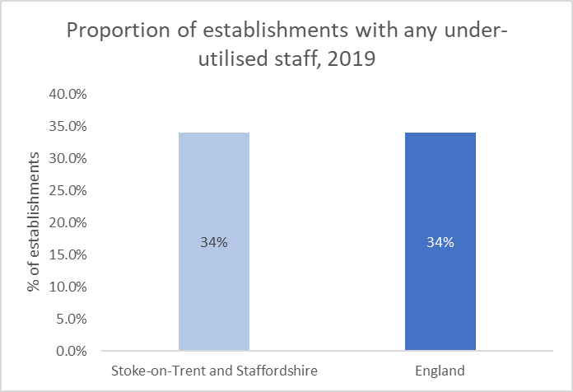

***Source:*** [*Employer Skills Survey, 2019 (published 2020), 2019 LEP boundaries*](https://www.gov.uk/government/publications/employer-skills-survey-2019-england-results)

In Stoke-on-Trent and Staffordshire businesses reported that there were 3.1% of staff which were not fully proficient at their job lower than the 4.6% seen nationally, while just over a third (34%) of businesses reported having under-utilised staff which was in-line with the national average.

This potentially suggests that locally there is currently a better alignment between skills supply and demand than is found nationally, however we have a higher proportion of jobs which are lower skilled, lower value roles and as we look to attract higher value, better paid jobs to the area there will be a need to ensure that the local workforce has the higher skills necessary to fill such roles.

Clearly, the fact that over a third of businesses across the country and locally have under-utilised staff is an area which needs to be better understood, as this may present opportunities to potentially develop businesses further through existing staff skills or provide the skills needed for the wider economy to grow and become more productive.

**Hard-to-fill and skills shortage vacancies:**

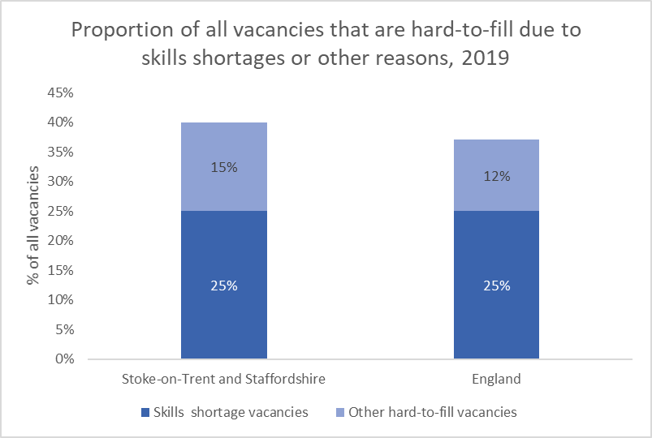

***Source:*** [*Employer Skills Survey, 2019 (published 2020), 2019 LEP boundaries*](https://www.gov.uk/government/publications/employer-skills-survey-2019-england-results)

In 2019 a fifth of vacancies reported by businesses in Stoke-on-Trent and Staffordshire were considered hard-to-fill due to skills shortages, while a further 15% were hard-to-fill for other reasons. Overall, 4 in 10 local vacancies were hard-to-fill which was higher than the 37% seen nationally.

The reasons for this higher likelihood of hard-to-fill vacancies are complex, but local intelligence suggest that there are a number of skills areas where there are issues. At a sectoral level there are notable issues between the supply and demand of skills, such as increasing need for STEM skills to drive growth in key priority sectors such as engineering and advanced manufacturing and MMO of construction. There are also increasing demands for more advanced digital skills across all sectors of the economy, such as advanced logistics and online retail. We also face a continuing shortage of health and social care workers e.g. nurses and care workers, alongside the need for new skills to support the transition to a greener economy.