|  |  |
| --- | --- |
|  |  |

Stoke-on-Trent and Staffordshire Apprenticeship

Recognition Awards 2016

Nomination Form

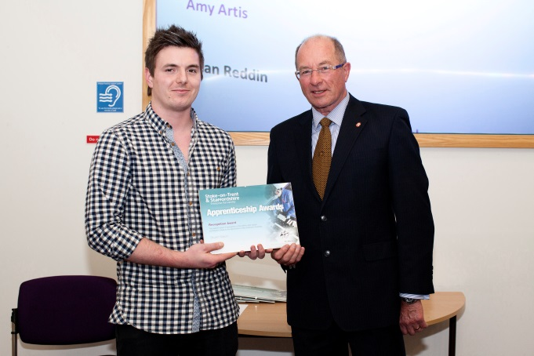

The Apprenticeship Recognition Awards have been held for 5 years. They showcase and celebrate the achievements of Apprentices who have exceeded expectations, shown an enthusiastic approach to learning, demonstrated initiative, enterprise, innovation and creativity and made a measurable impact within their jobs. **Could one of your Apprentices win this year?**

Outstanding achievements of Apprentices also demonstrate the strong commitment made by you, as an employer or training provider, to develop the innovation and enterprise that contributes to the social and economic growth of our area.

**The winners will receive their award and prize at a presentation ceremony on Thursday 10th March 2-00 pm (venue to be confirmed)**

**To nominate your Apprentice please complete this form and return it to**

**Chris Bamsey** – [chris.bamsey@staffordshire.gov.uk](mailto:chris.bamsey@staffordshire.gov.uk).



**Last date for entry will be 19th February 2016**

## Employer and Apprentice Information

| Employer Name |  |
| --- | --- |
| Contact Email |  |
| Address |  |
| Apprentice Name |  |
| Training Provider |  |
| Contact Email |  |

## Age Category for Apprentice (please tick)

|  |  |  |  |  |
| --- | --- | --- | --- | --- |
|  | | | | |
| **19 – 24 Years** | **16 -18 years** | **19 – 24 years** | **25 years and over** |  |

## Apprenticeship Level (please tick)

|  |  |  |  |  |  |
| --- | --- | --- | --- | --- | --- |
|  | | | | | |
| **19 – 24 Years** | **Intermediate** | | **Advanced** | **Higher** |  |
| Nominating Employer Company Size (please tick) | | | | |
|  | **Small Employer (1-24 employees)** | **Medium Employer (25-249 employees)** | **Large Employer (250-4,999 employees)** |  |

These awards offer a great platform for Apprentices, employers and training providers to gain recognition so **please detail below why you think that your Apprentice should be a winner;**

|  |
| --- |
| **1. What special qualities, attributes and skills make your Apprentice stand out from the rest and make them a winner?**  **i.e. outstanding work ethic, ability to use initiative, outstanding team contribution etc.** |
| **2. Please give at least 2 examples of how your Apprentice has contributed to and improved your business? Please detail specifically how his/her actions, enterprise and innovation have made a difference within your business? i.e. improved profit, improved systems, increased orders, time saving, product development, reduced overheads etc**  Please add as much detail as you can that demonstrates how their performance is over and above what is expected as the competition in previous years as been strong and selection of your nominee relies on the information detailed here. |

The Apprenticeship Recognition Awards are supported by Stoke-on-Trent City Council, Staffordshire County Council, Staffordshire & Stoke-on-Trent Local Enterprise Partnership (LEP), local employers and all partner organisations engaged in providing quality Apprenticeships to develop businesses and drive forward the local economy.

  