STOKE ON TRENT & STAFFORDSHIRE
LOCAL ENTERPRISE PARTNERSHIP
COMPANY EXECUTIVE BOARD MEETING
16 July 2020
LEP Secretariat: Recruitment to the position of the Chief Executive

Background
- The role of the Chief Executive is set out in the Assurance Framework under page 39. For ease of reference it can be found here: https://www.stokestaffslep.org.uk/app/uploads/2020/04/SSLEP-Assurance-Framework-April-2020-v-7.pdf and an extract is provided below:

The role and responsibilities of the Chief Executive Officer will be to provide energetic & visionary leadership in:
- Setting & driving the strategic direction for SSLEP, working with Directors
- Leading on strategic partner & stakeholder engagement including the development & delivery of the Business Engagement Strategy, working with Chair & Board
- Providing the LEP public face & leading delivery of the Communications Strategy
- Working with Communications Officer to coordinate internal communications for the Directors, partners and staff
- Leading on the Board Member Induction & Refresh Programme
- Developing & managing LEP finance & budget and ensuring best value for money, working with the Chair of Audit & Finance and S151 Officer
- Providing the Company Secretary compliance role on Assurance Framework

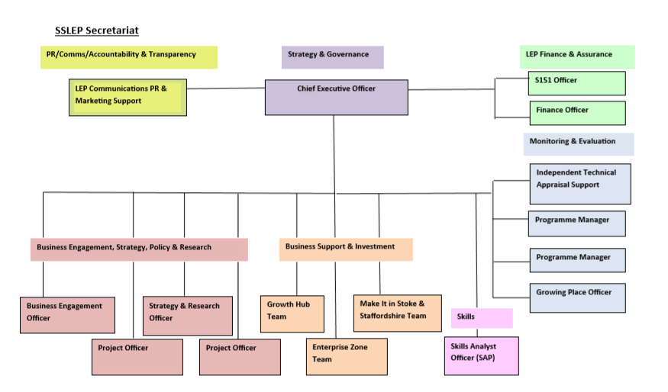

- Following adoption of the Assurance Framework v7 in April 2020, the SSLEP is now in a position to recruit to the Chief Executive position (the incumbent is Mark Parkinson through a secondment arrangement with the Accountable Body in Staffordshire County Council).
Proposed Next Steps

- It is proposed that a Task – Finish Committee (the Committee) is established to oversee the recruitment process and comprises the Chairman of the LEP, Vice-Chairman of the LEP, two of the SSLEP Chairman and Vice-Chairman roles from the Decision Making / Operational Boards/Groups, the Equality & Diversity Champion, the Accountable Body in Staffordshire County Council, Stoke-on-Trent City Council, one Borough/District Council representative and the SSLEP S151 Officer.

- It is proposed the Committee members comprise:

- Caroline Brown, Vice-Chairman of the Audit & Finance Committee
- Sinead Butters, Vice-Chairman of the Strategic Programme Management Group
- James Leavesley, Vice-Chairman of the LEP & Chairman of the SPMG
- Alun Rogers, Chairman of the LEP
- Sara Williams, Equality & Diversity Champion
- Accountable Body representative c/o Staffordshire County Council
- Cllr Abi Brown, Stoke-on-Trent City Council
- One Cllr, from the Borough/District Councils (to be decided amongst themselves).
- Simon Ablewhite, SSLEP S151 Officer

- It is proposed that either the current Chief Executive (or S151 Officer should the Chief Executive have the conflict of interest in wishing to be an applicant) will provide the Committee with the option of support from an external advisor experienced in executive recruitment.

RECOMMENDATION
That LEP Executive Board Members endorse:
- Initiating the recruitment process for the post of Chief Executive of the SSLEP.

- That a Task and Finish Committee is established to oversee the process comprising the Chairman of the LEP, Vice-Chairman of the LEP, two of the SSLEP Chairman and Vice-Chairman roles from the Decision Making / Operational Boards/Groups, the Equality & Diversity Champion, the Accountable Body in Staffordshire County Council, Stoke-on-Trent City Council, one Borough/District Council representative and the SSLEP S151 Officer

- That the Committee membership will comprise:
  - Caroline Brown, Vice-Chairman of the Audit & Finance Committee
  - Sinead Butters, Vice-Chairman of the Strategic Programme Management Group
  - James Leavesley, Vice-Chairman of the LEP & Chairman of the SPMG
  - Alun Rogers, Chairman of the LEP
  - Sara Williams, Equality & Diversity Champion
  - Accountable Body representative c/o Staffordshire County Council
  - Cllr Abi Brown, Stoke-on-Trent City Council
  - One Cllr, from the Borough/District Councils (to be decided amongst themselves).
  - Simon Ablewhite, SSLEP S151 Officer

- That the LEP Secretariat will provide the Committee with the option of professional support from an external advisor experienced in executive recruitment.

Board Lead: Alun Rogers, SSLEP Chairman
Secretariat Lead: Simon Ablewhite, S151 Officer, SSLEP
Report Author: Mark Parkinson, Chief Executive, SSLEP

